Tour ID: 260127  
Tour Name: Iceland and Beyond - Reykjavík to Hamburg via Scotland's Northern Isles

Tour destinations: ['Reykjavik', 'Heimaey Island', 'Grundarfjordur', 'Snæfellsnes', 'Isafjordur', 'Akureyri', 'Godafoss', 'Husavik', 'Bakkagerdi', 'Vatnajokull National Park', 'Lerwick', 'Fair Isle', 'Orkney Islands', 'Hamburg']

Tour destinations images:

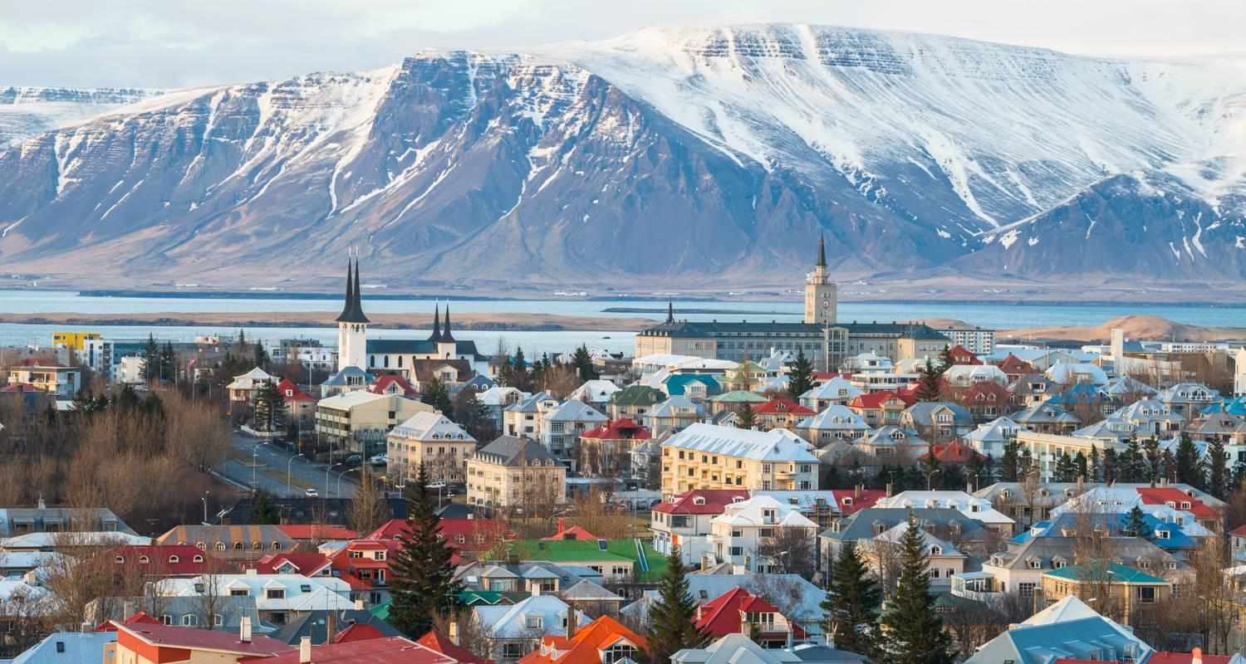

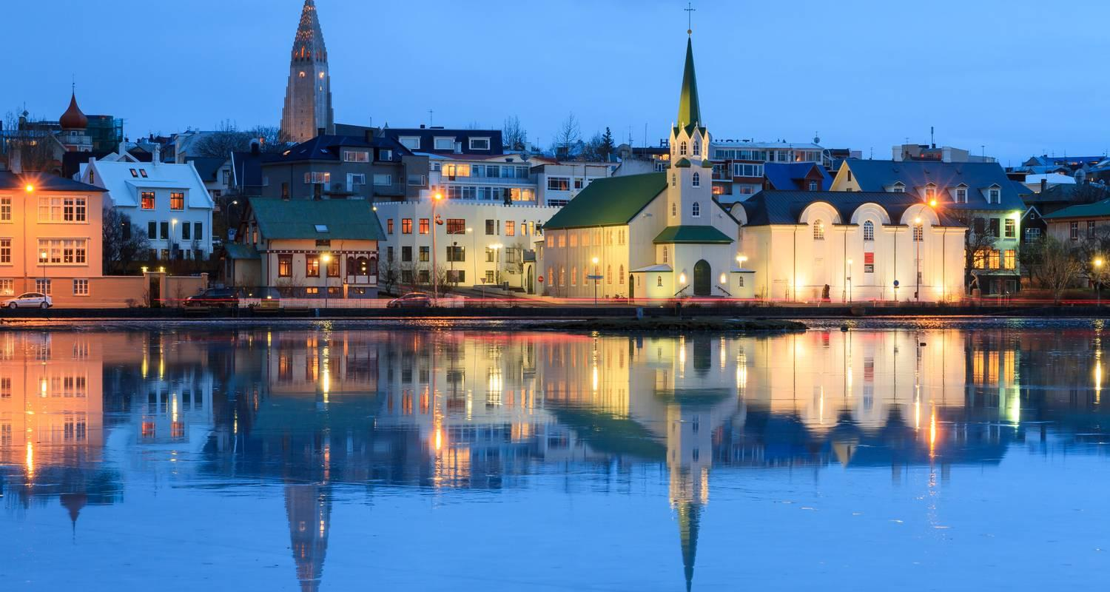

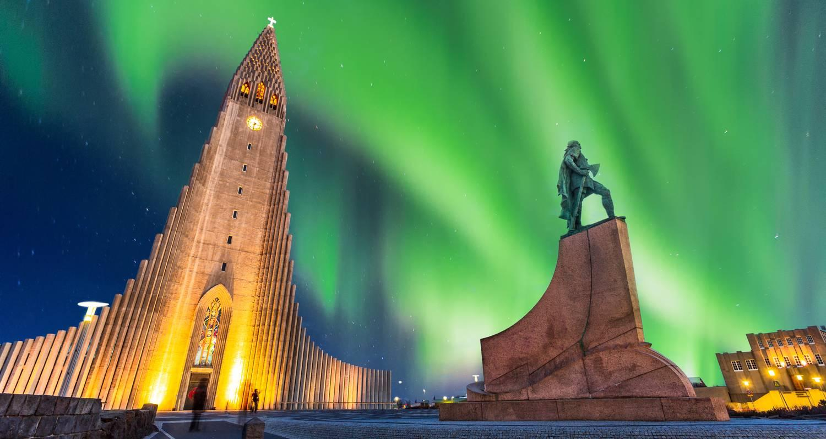

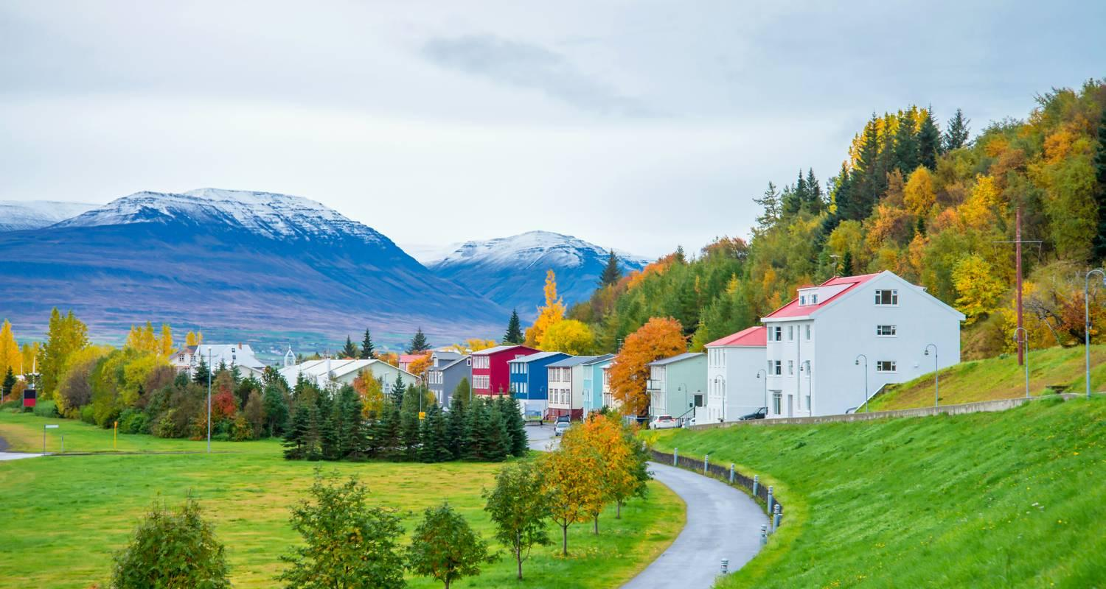

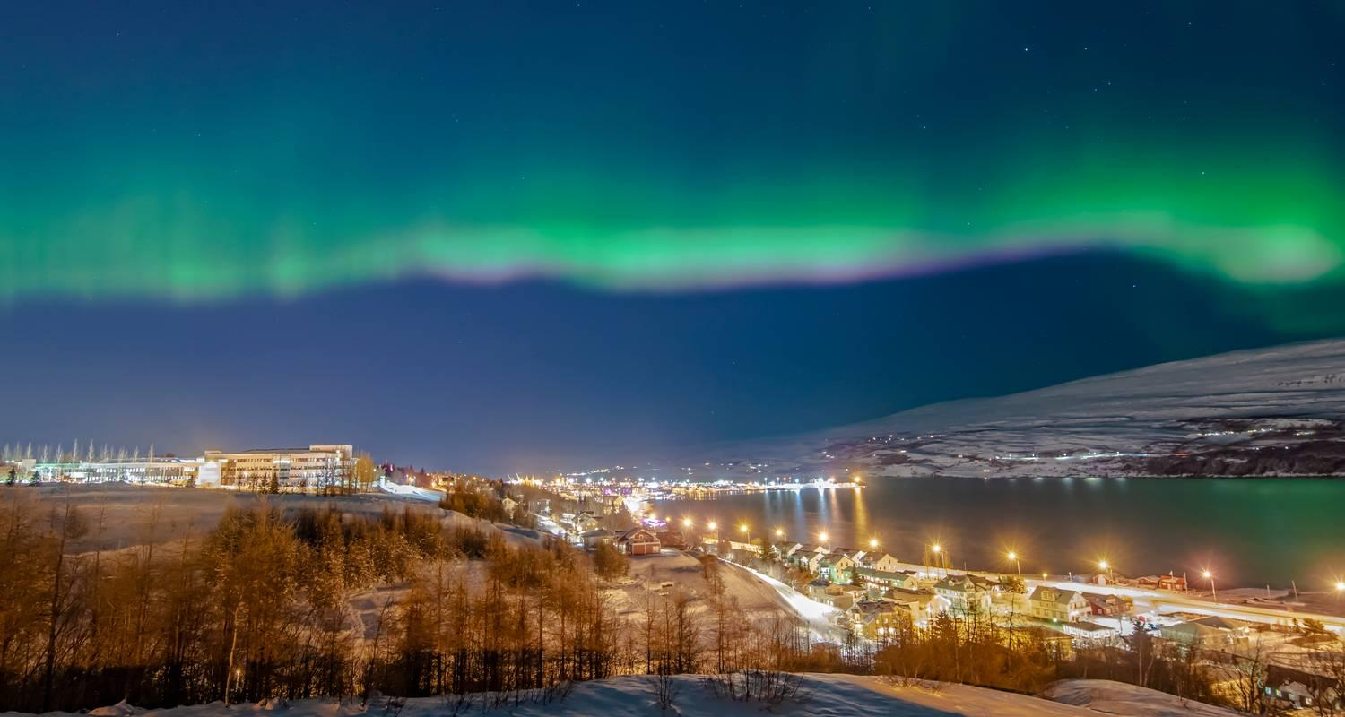

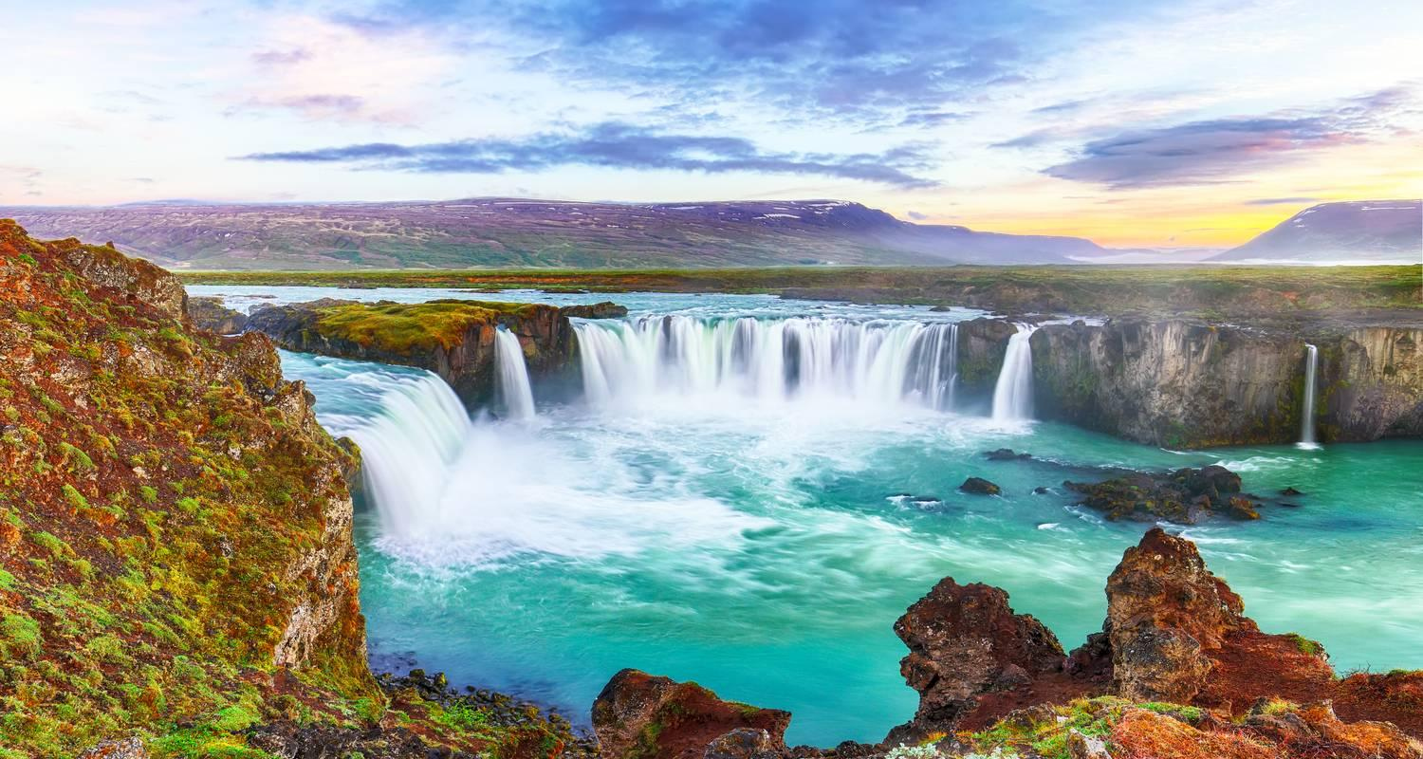

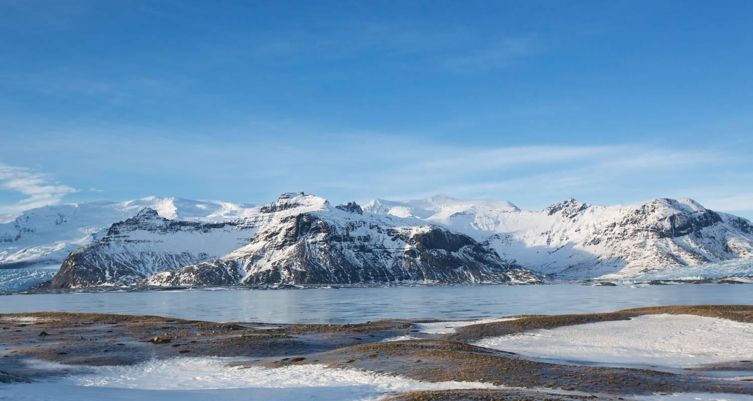

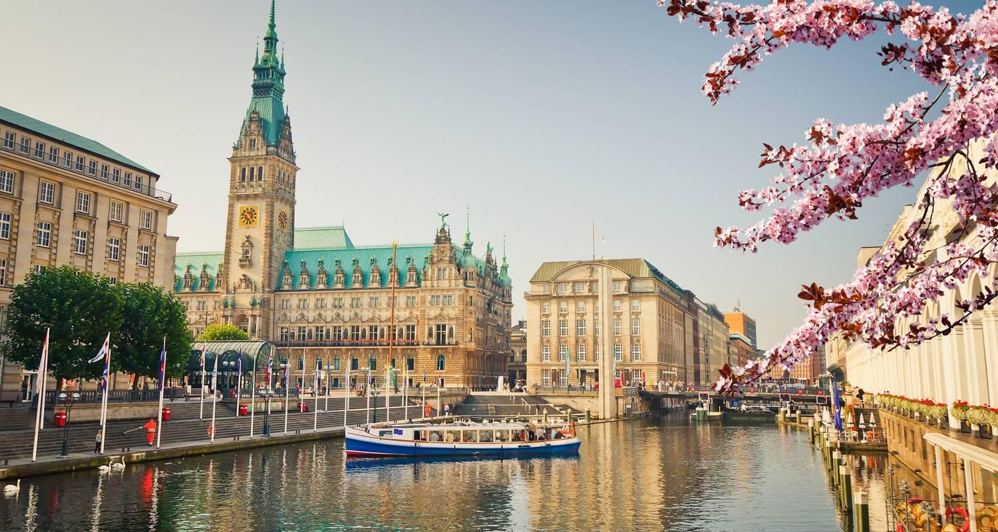

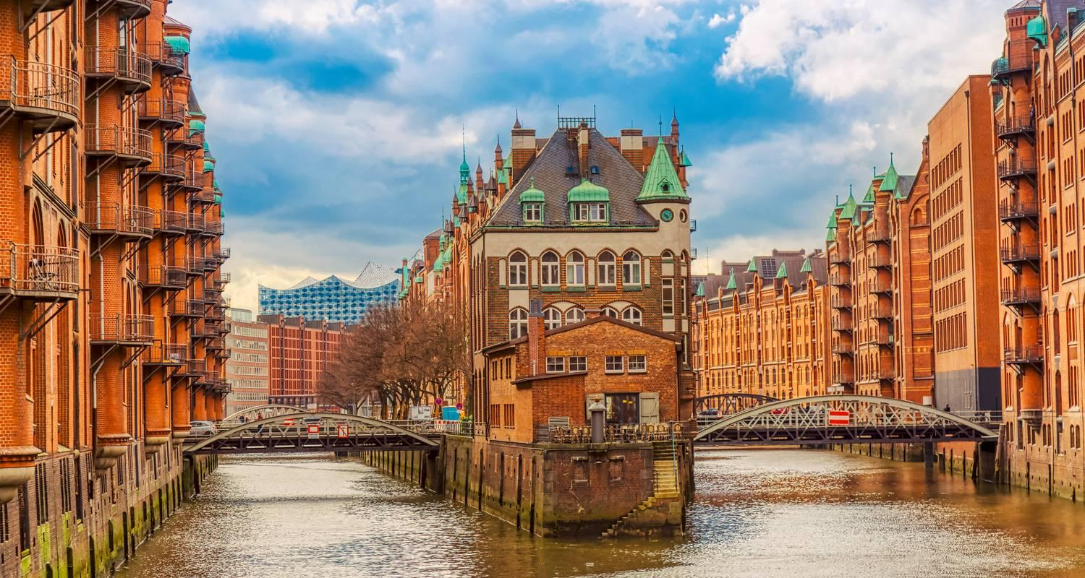

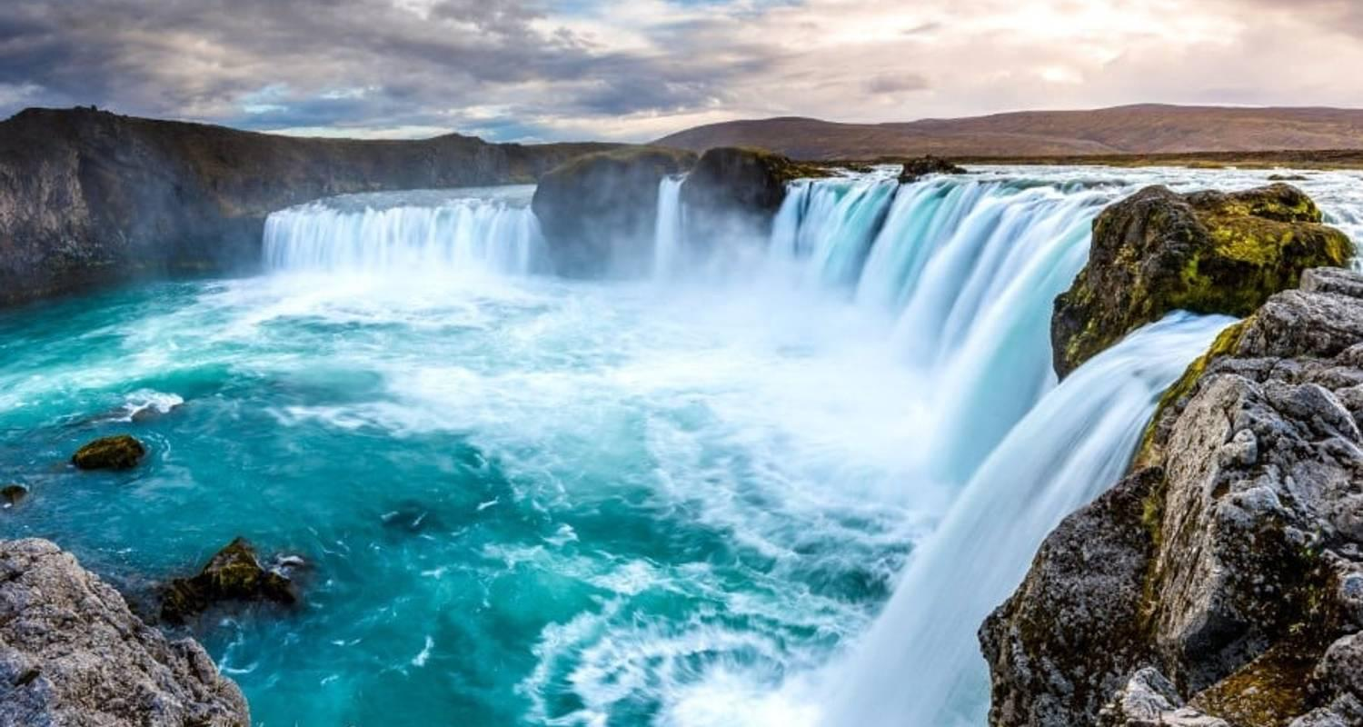

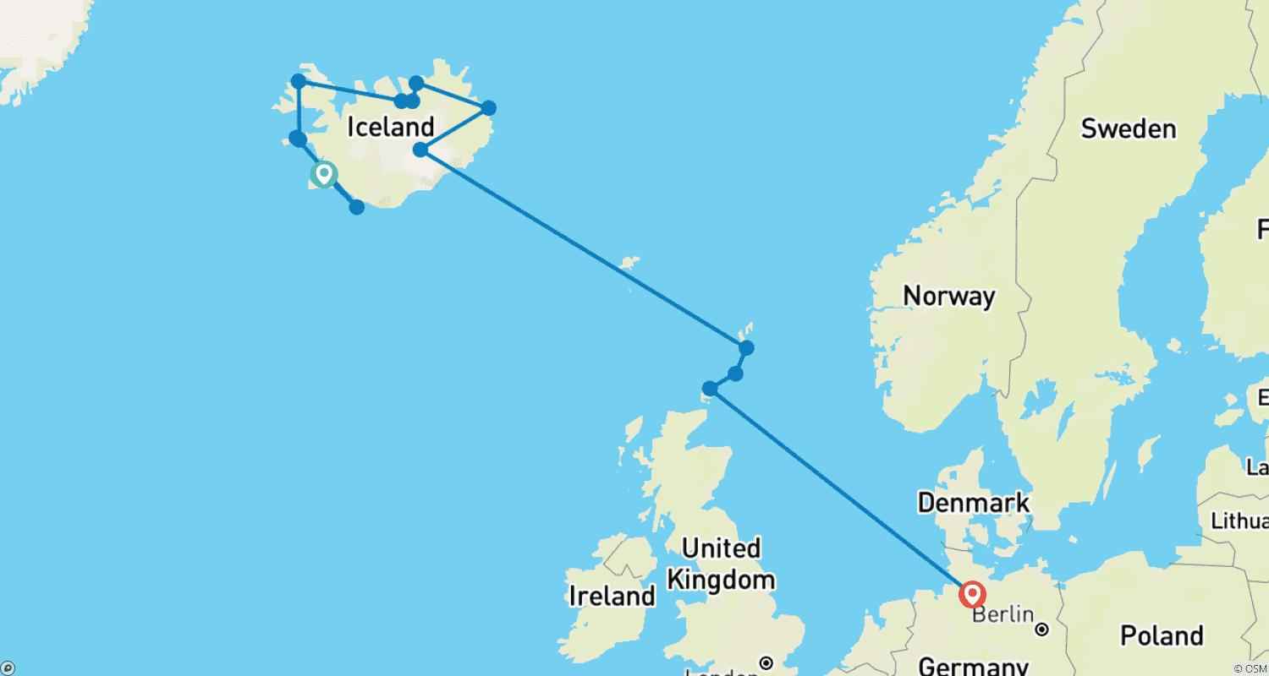

Tour ID: 260152  
Tour Name: Greenland - Hiking Tours in the Pearl of the Arctic

Tour destinations: ['Keflavik', 'Kulusuk', 'Tasiilaq', 'Kuummiit', 'Knud Rasmussen Gletscher', 'Reykjavik']

Tour destinations images:

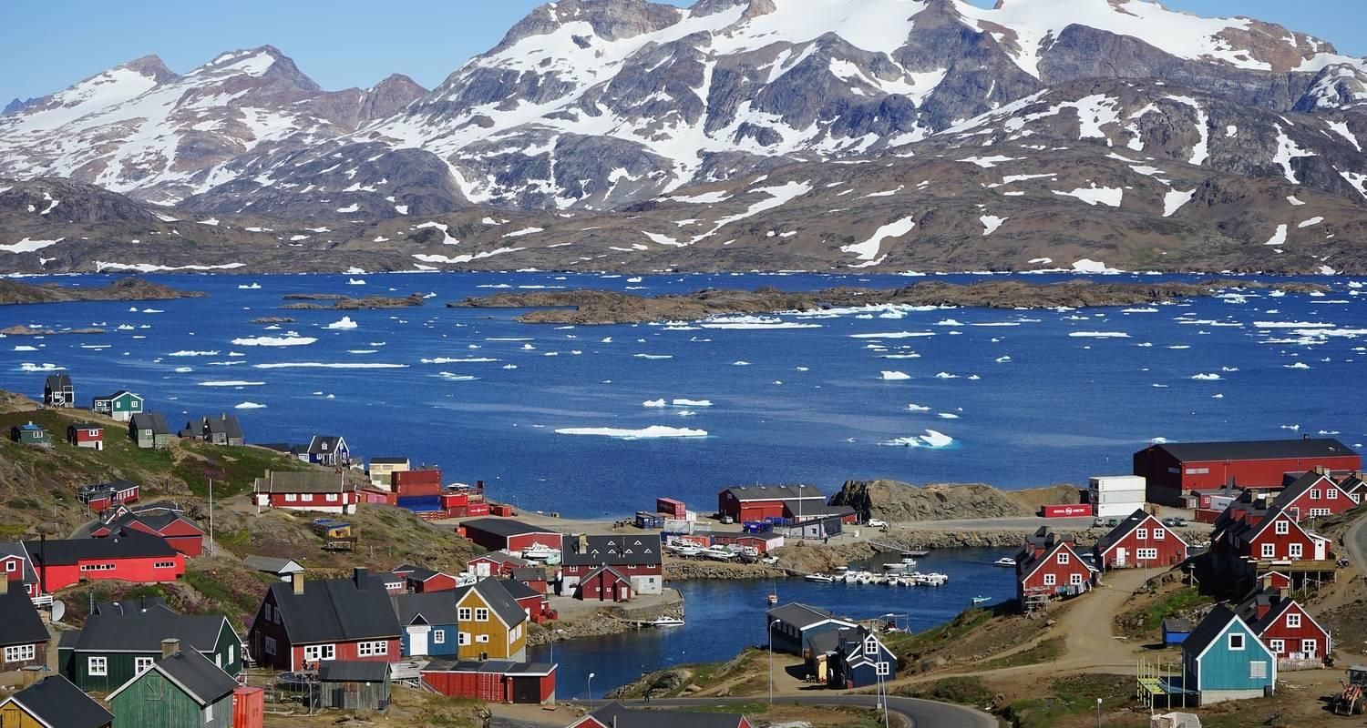

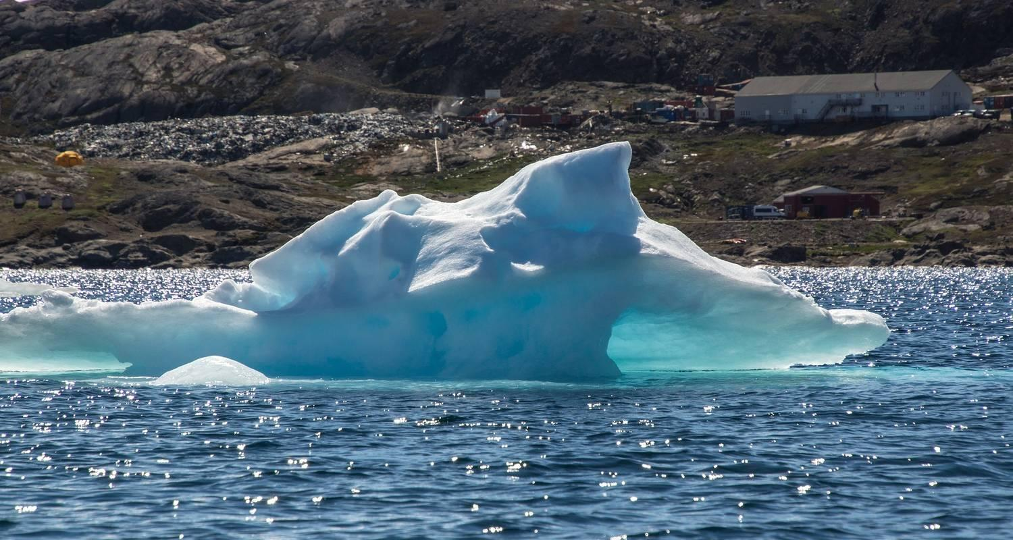

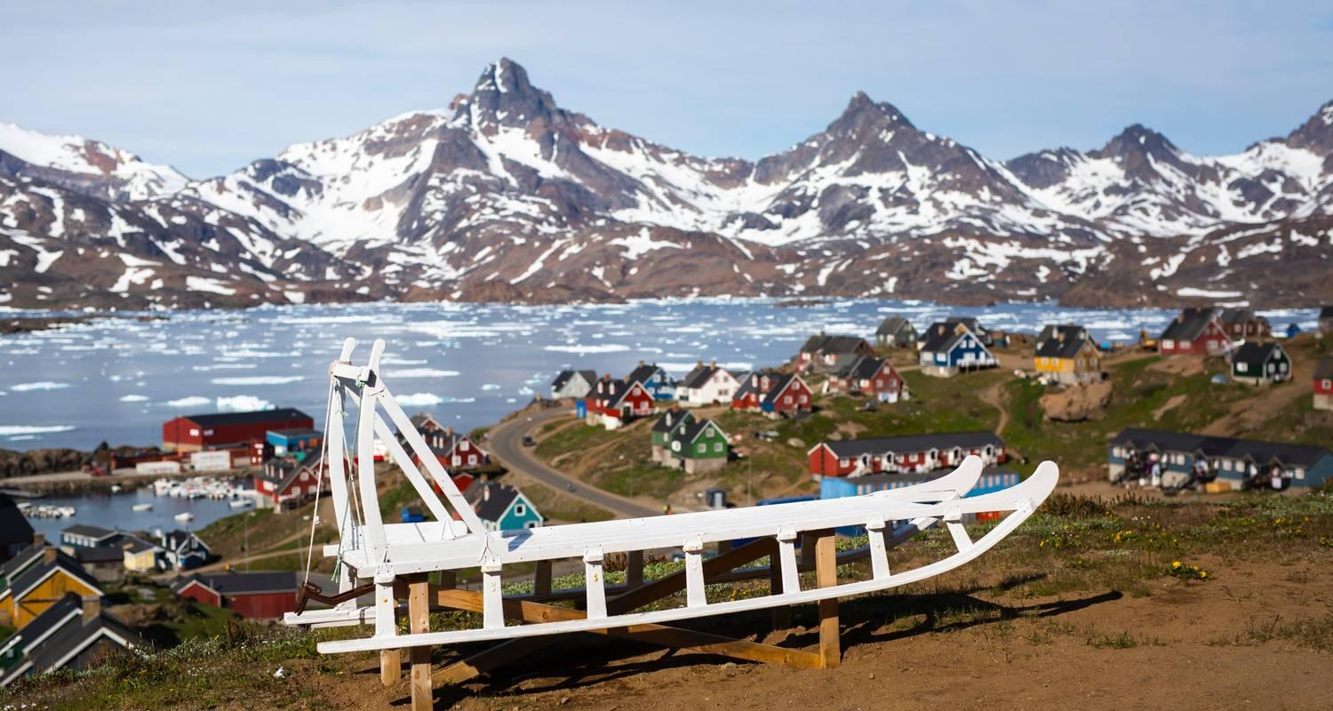

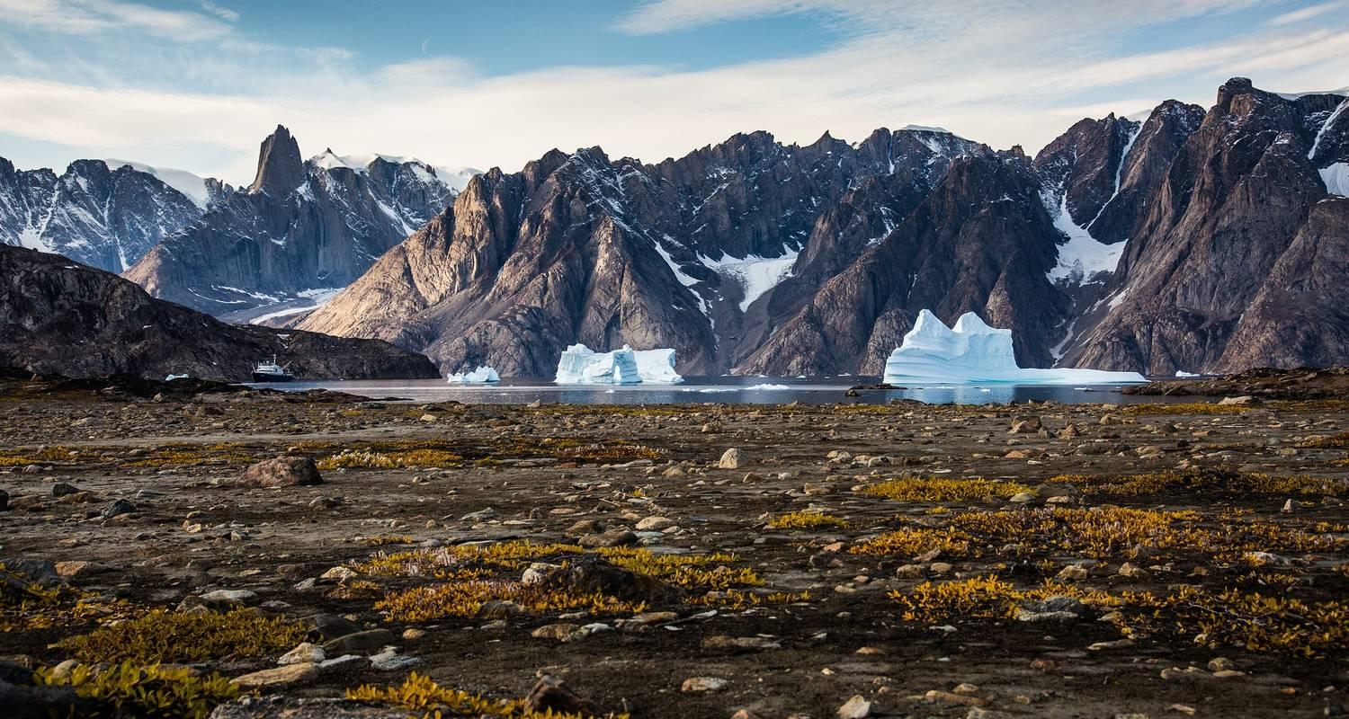

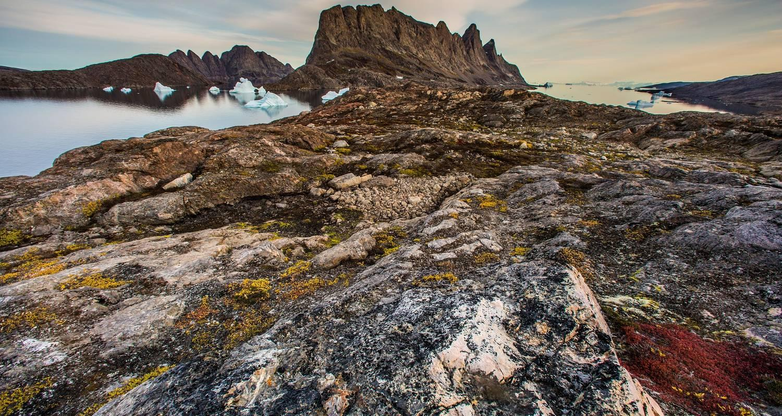

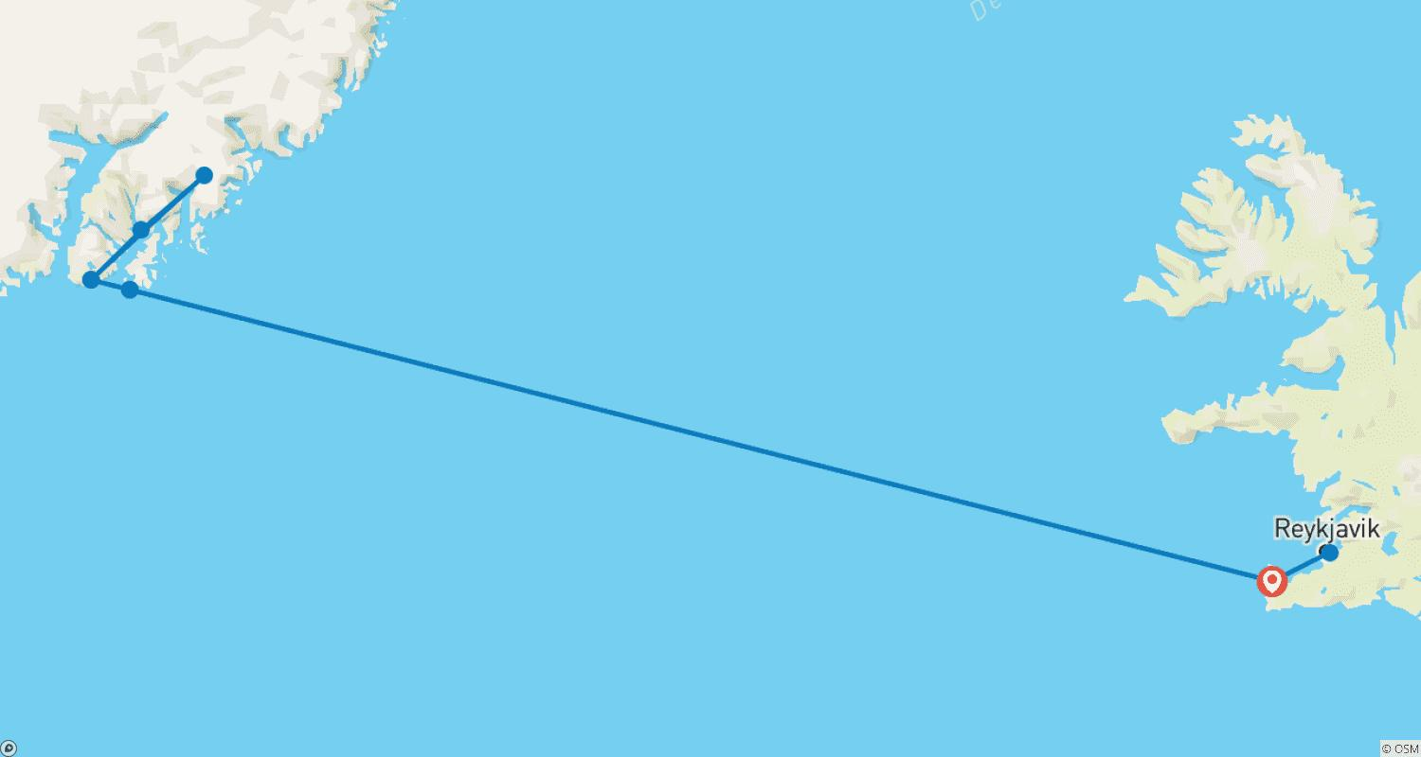

Tour ID: 260156  
Tour Name: Iceland Adventure

Tour destinations: ['Keflavik', 'Reykjavik', 'Gullfoss', 'Hveravellir', 'Akureyri', 'Myvatn', 'Vatnajokull National Park', 'Askja', 'Vik']

Tour destinations images:

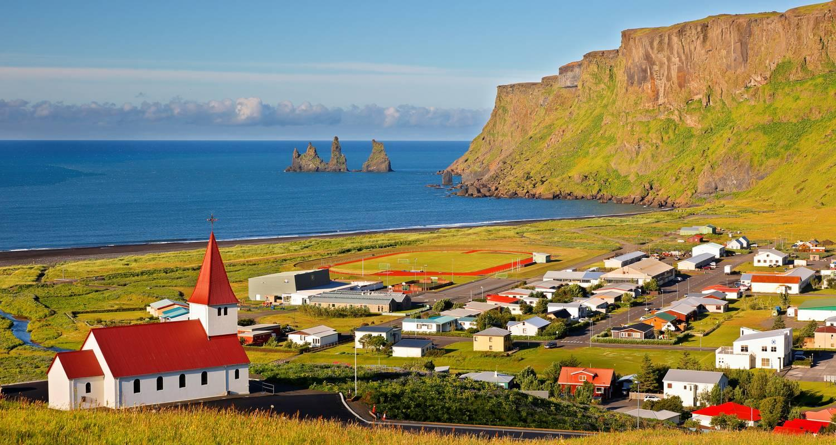

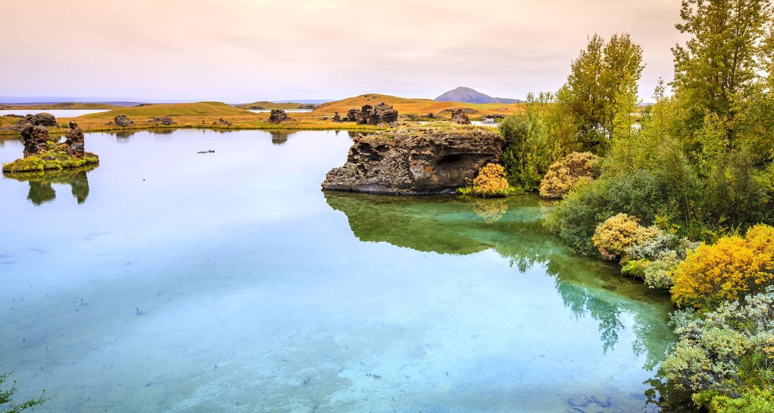

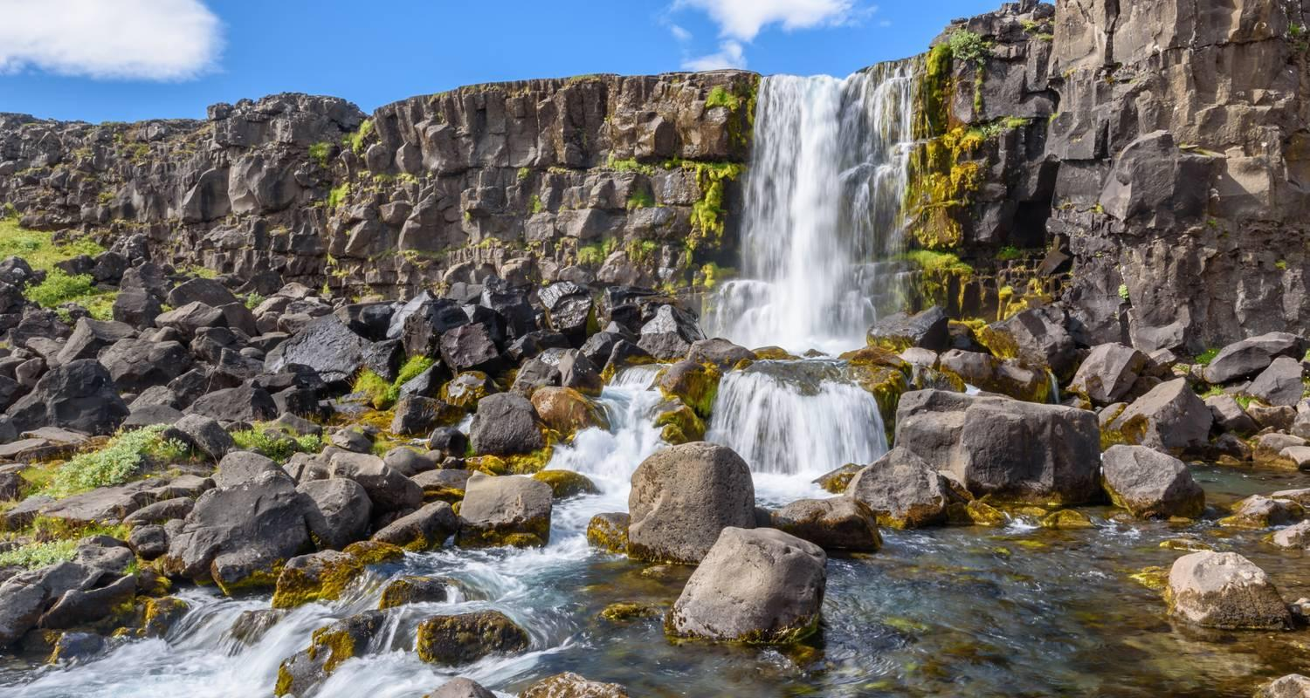

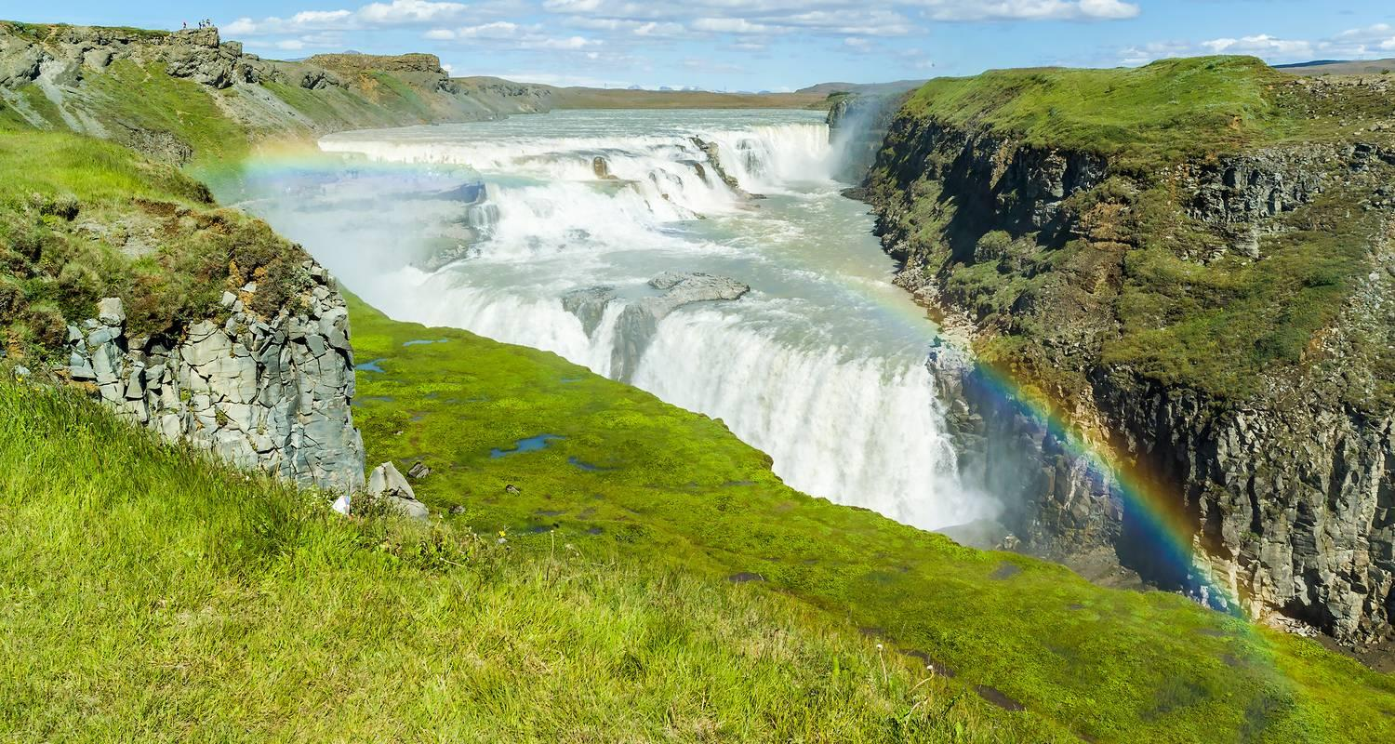

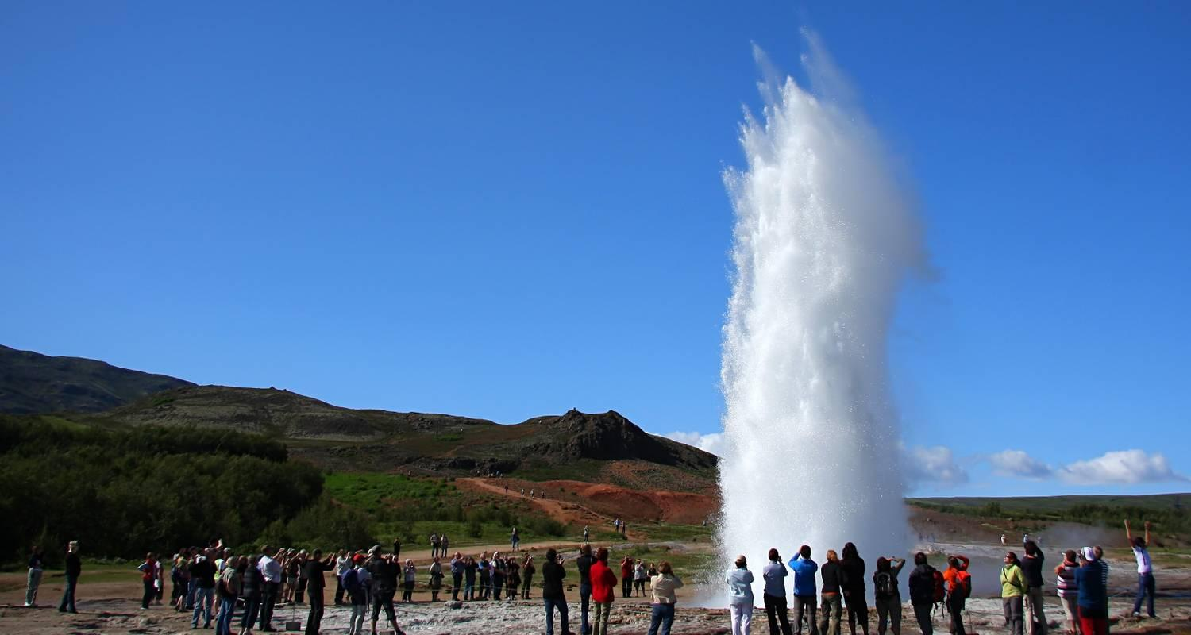

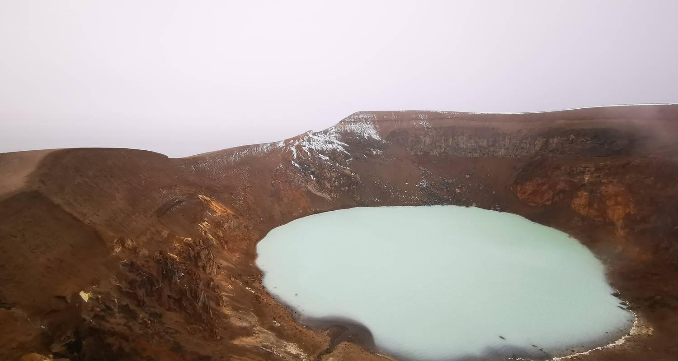

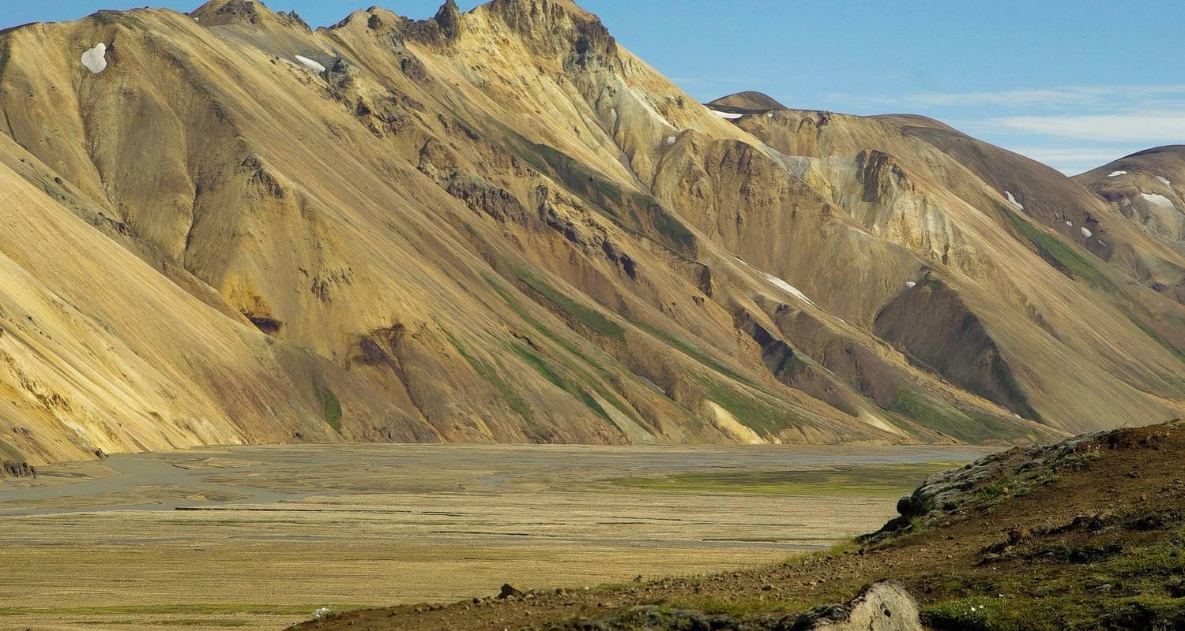

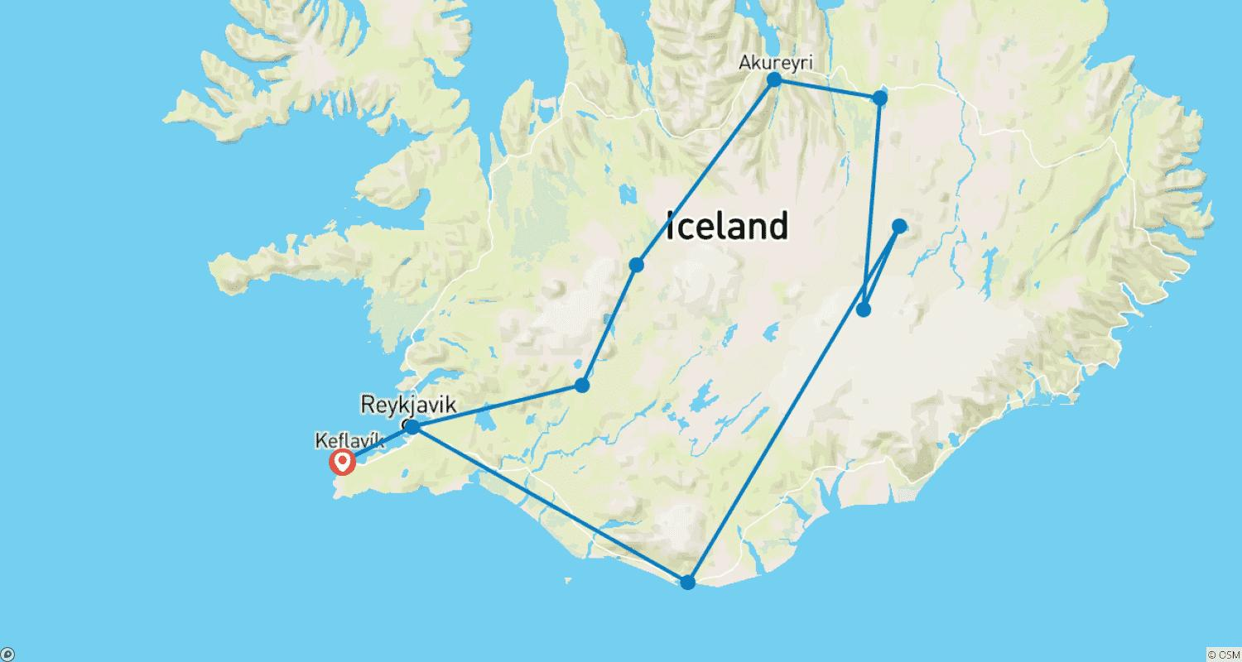

Tour ID: 260253  
Tour Name: Iceland's Green Side - Circumnavigation of the Island

Tour destinations: ['Keflavik', 'Reykjavik', 'Vik', 'Skaftafell', 'Jokulsarlon', 'Hofn', 'Djupivogur', 'Egilsstadir', 'Myvatn', 'Dettifoss', 'Asbyrgi Canyon', 'Husavik', 'Godafoss', 'Akureyri', 'Dalvik', 'Blonduos', 'Snaefellsjokull National Park', 'Thingvellir National Park', 'Geysir', 'Gullfoss']

Tour destinations images:

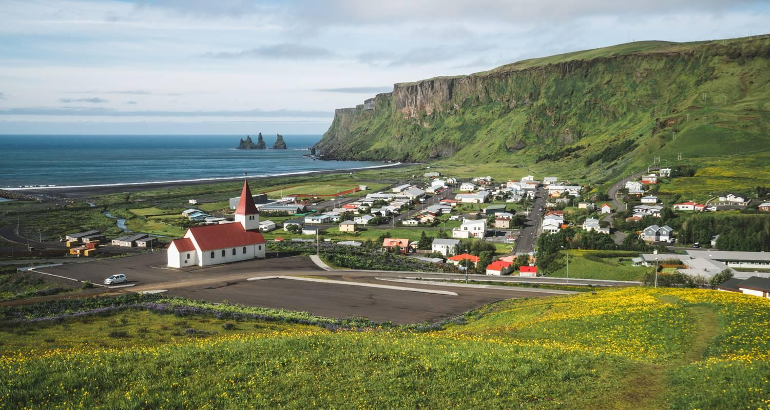

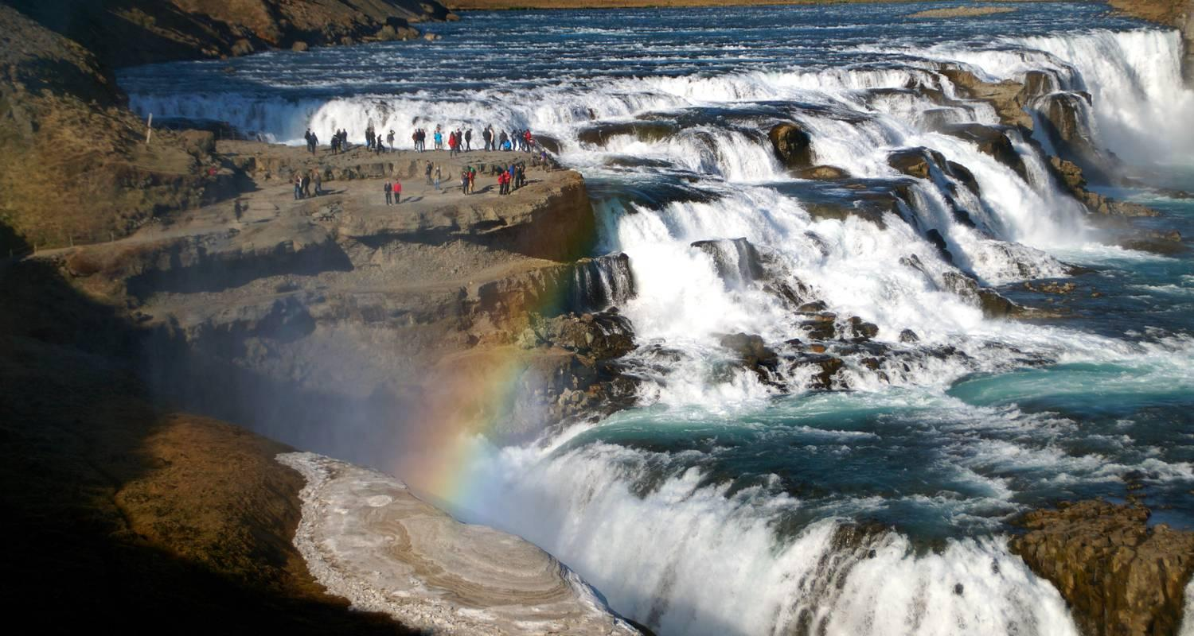

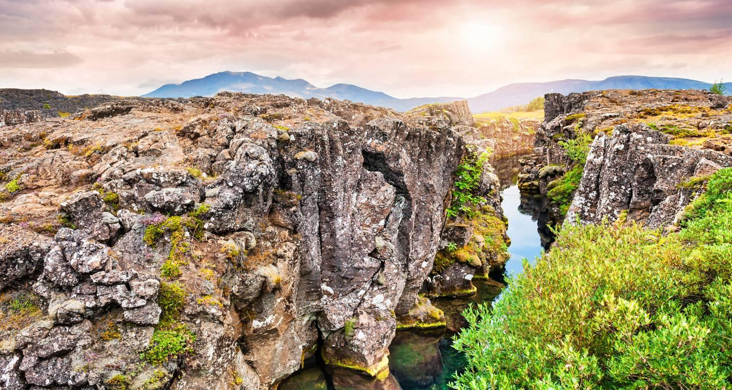

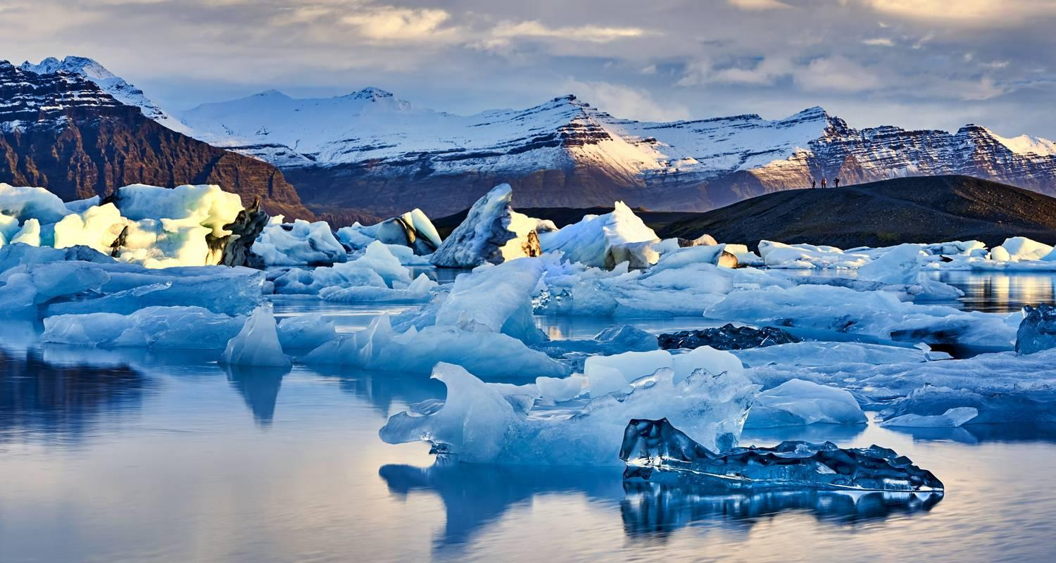

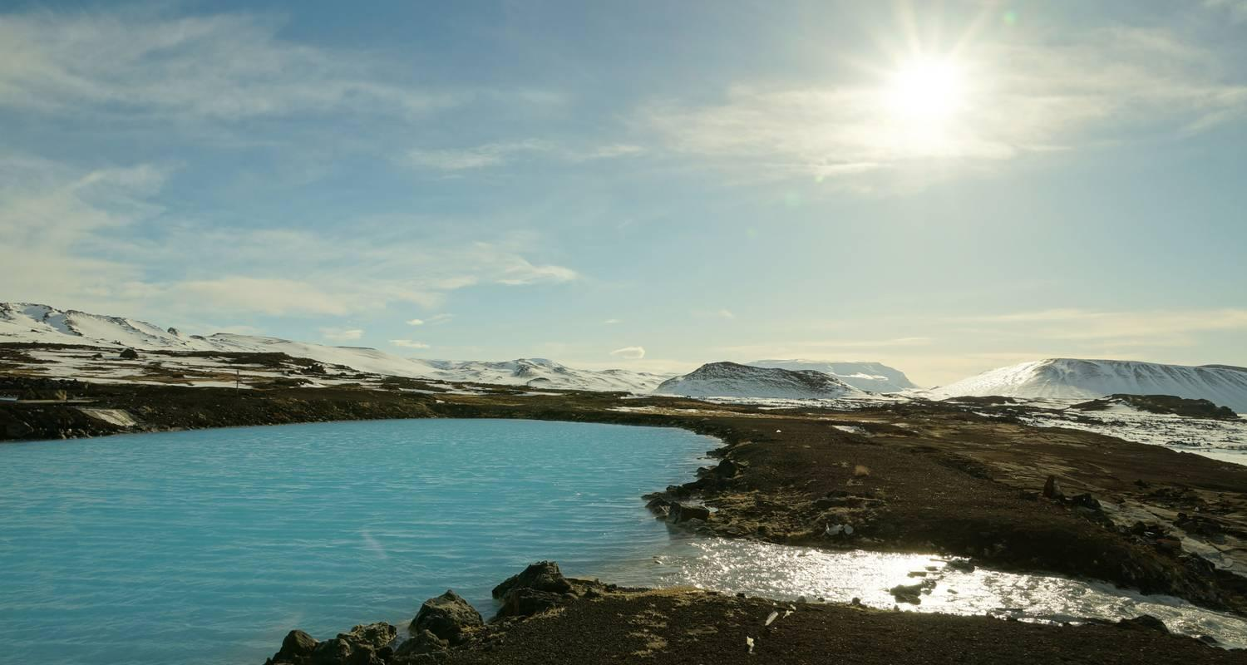

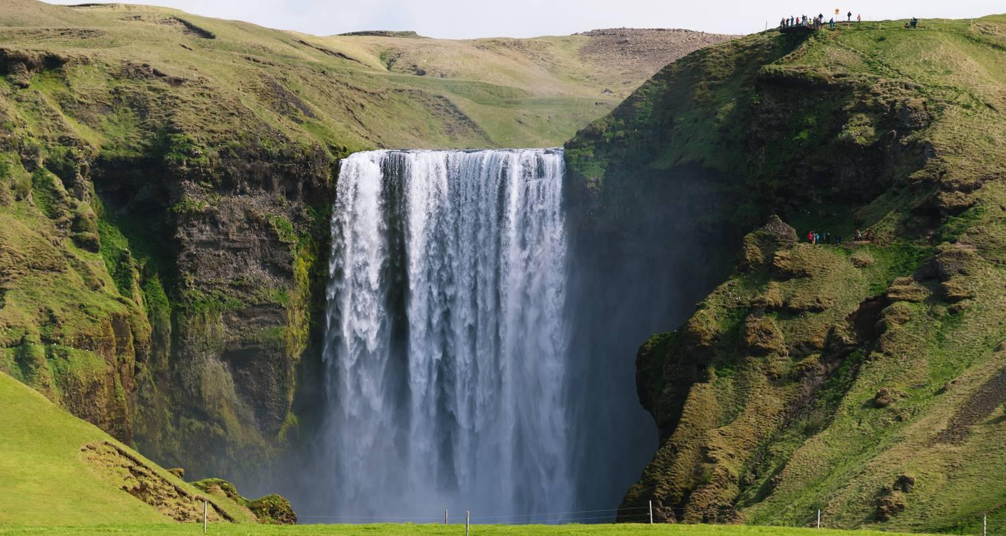

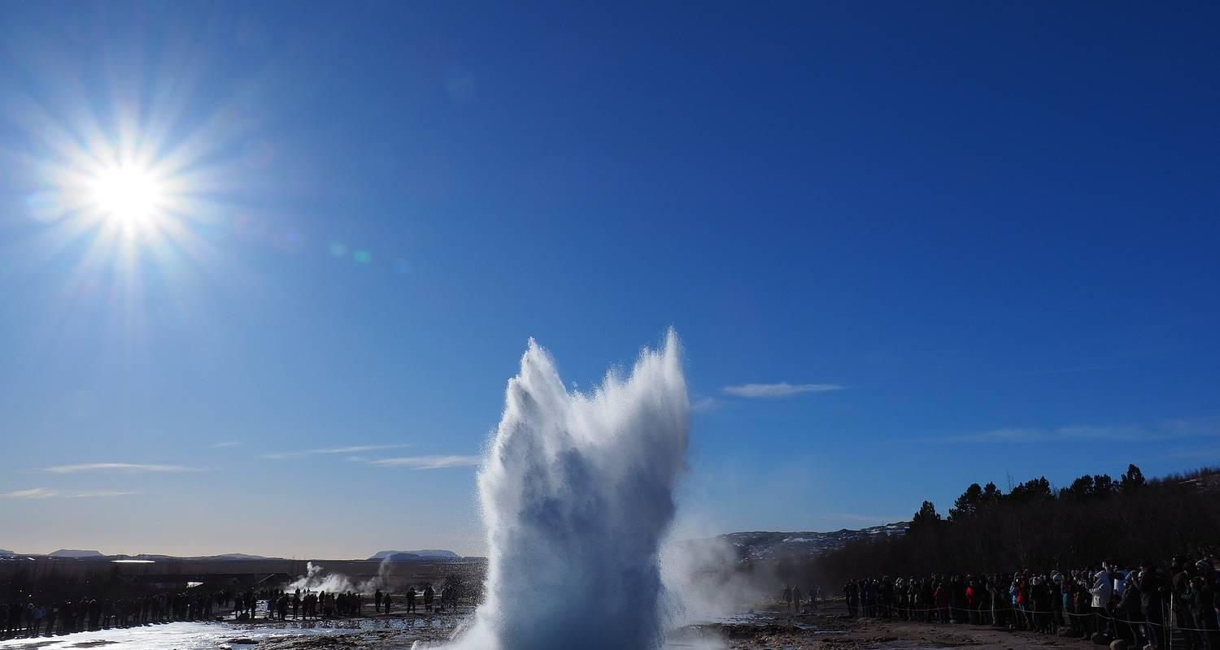

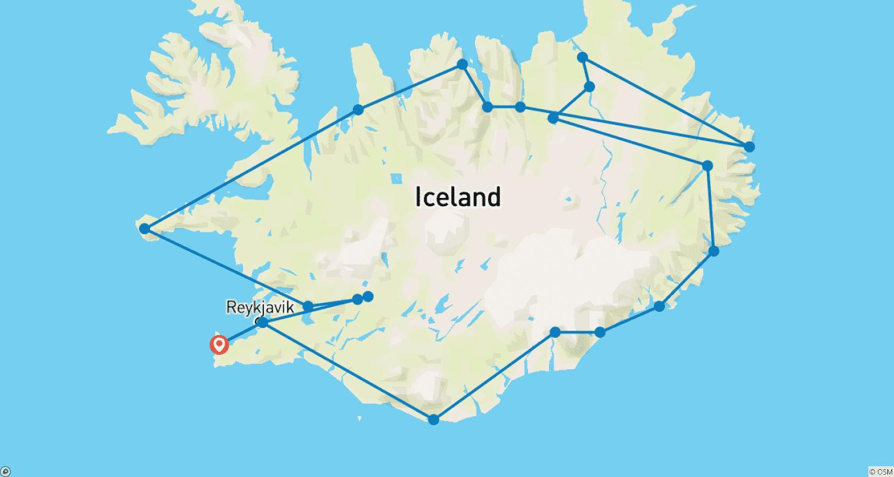

Tour ID: 260254  
Tour Name: Iceland Highlights

Tour destinations: ['Keflavik', 'Reykjavik', 'Thorsmork Nature Reserve', 'Vatnajokull National Park', 'Skaftafell', 'Landmannalaugar', 'Fludir', 'Gullfoss', 'Geysir', 'Thingvellir National Park']

Tour destinations images:

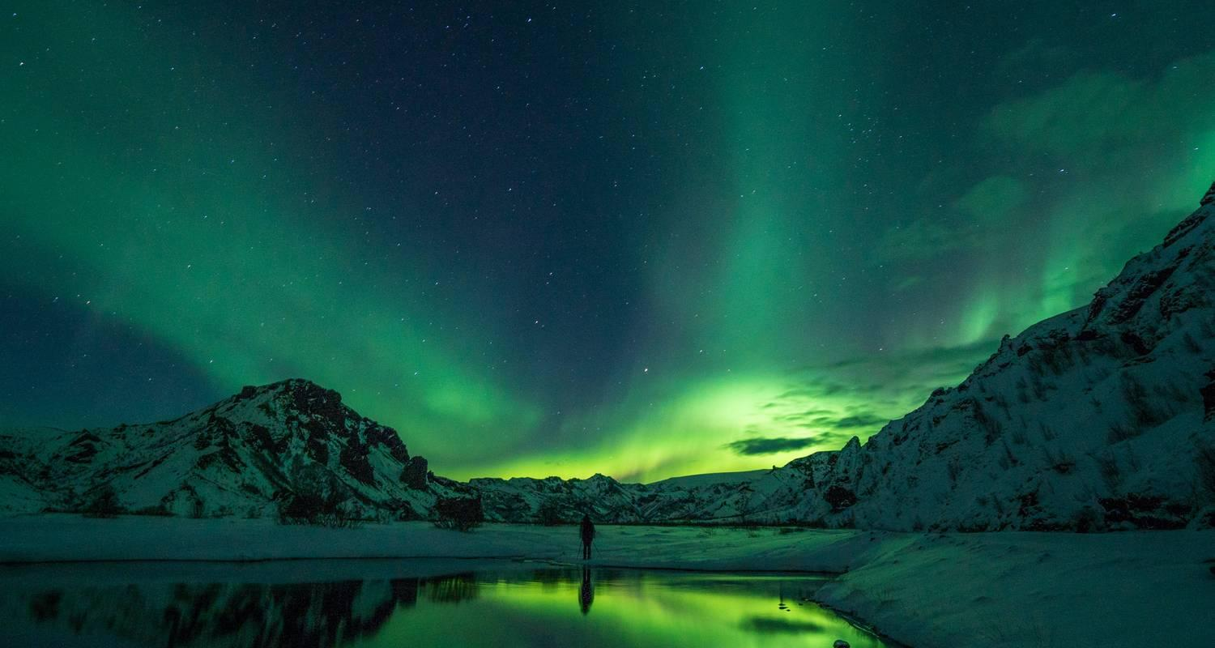

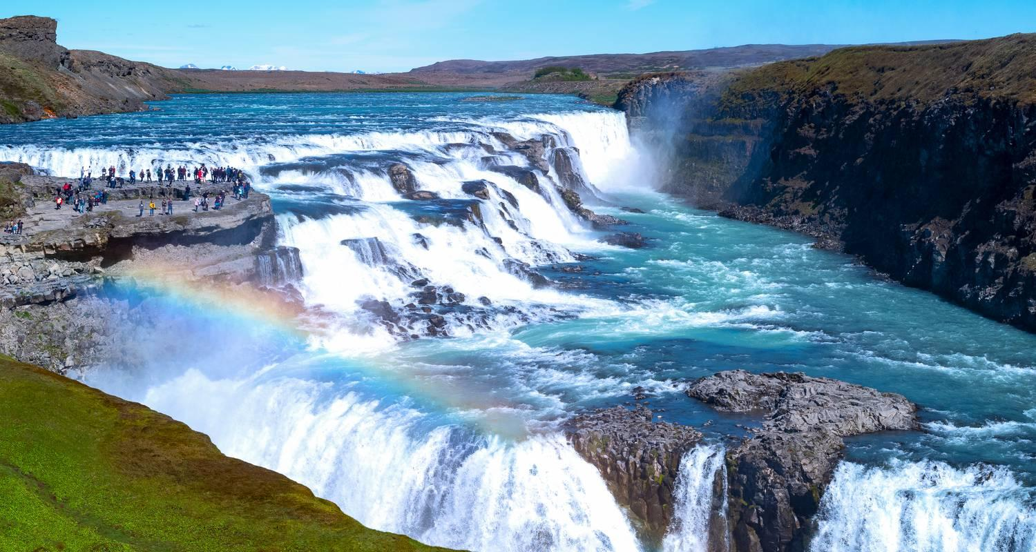

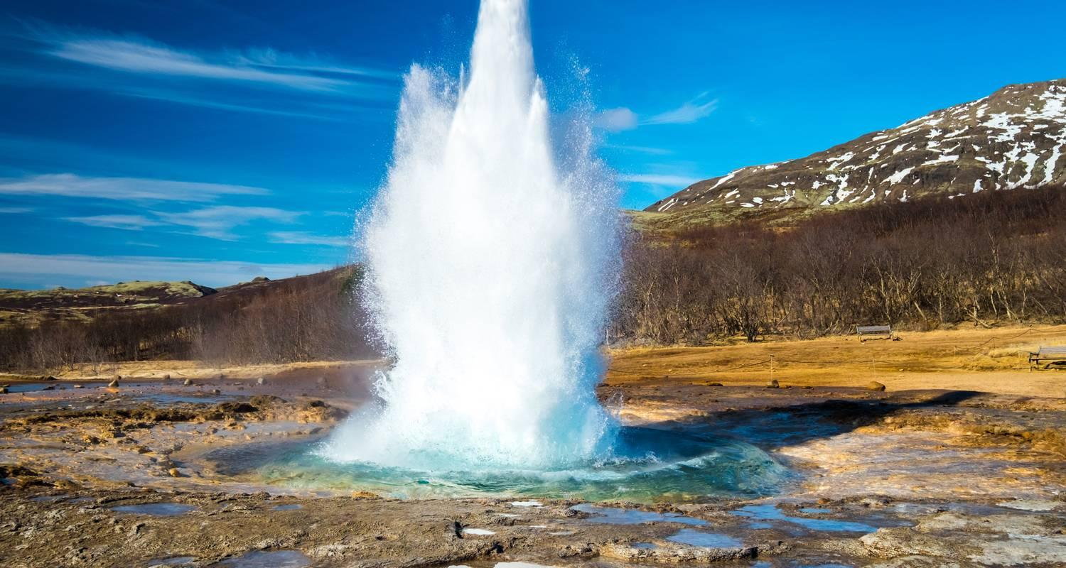



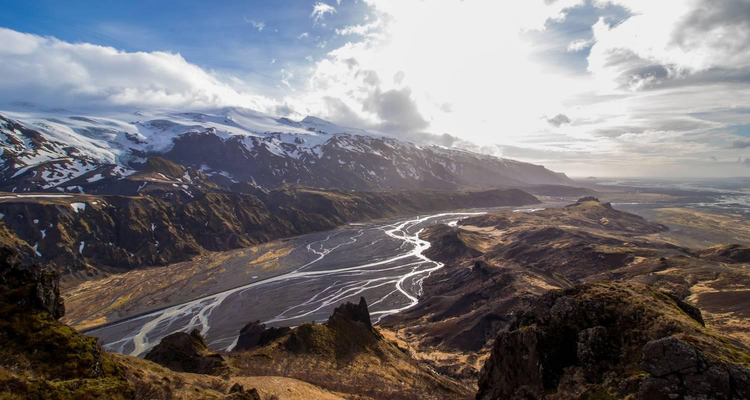

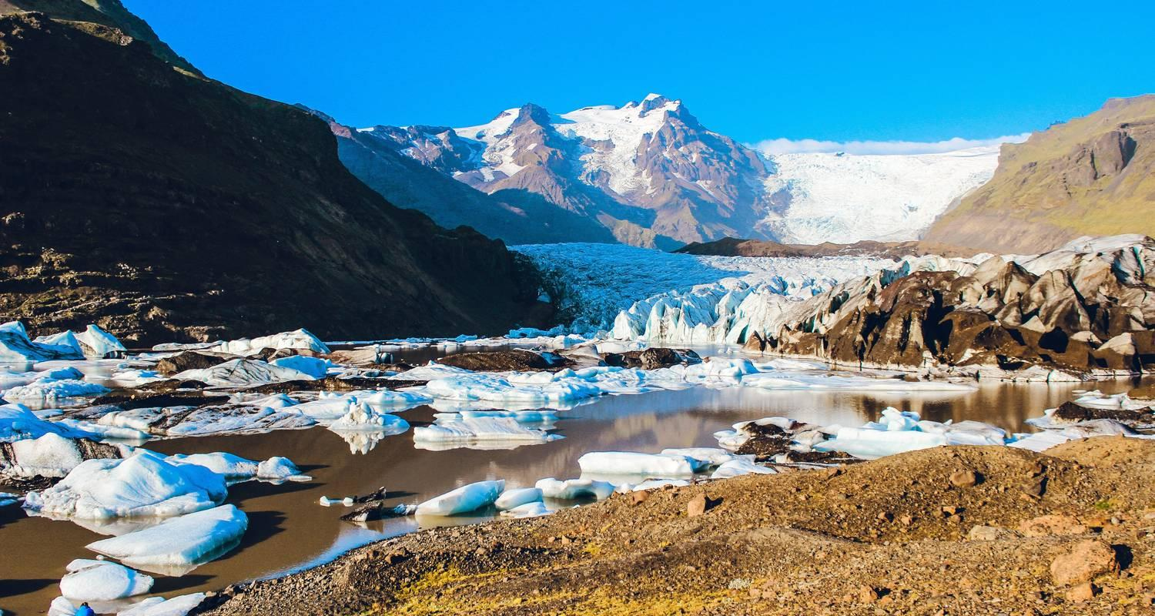

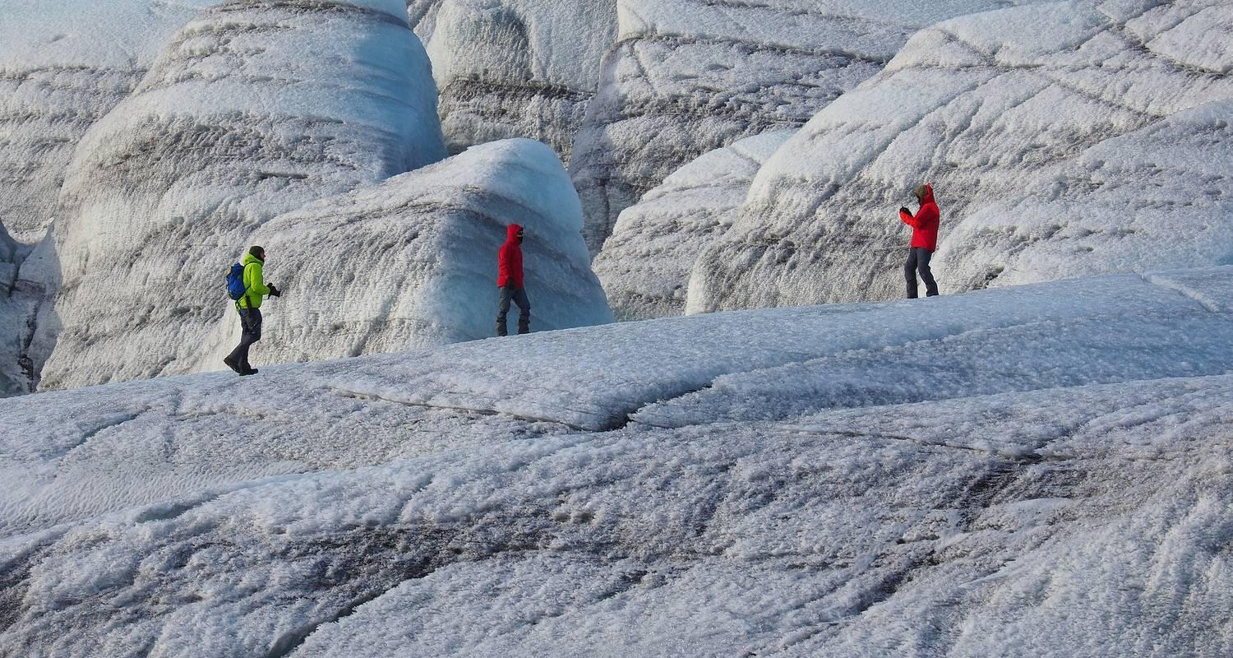



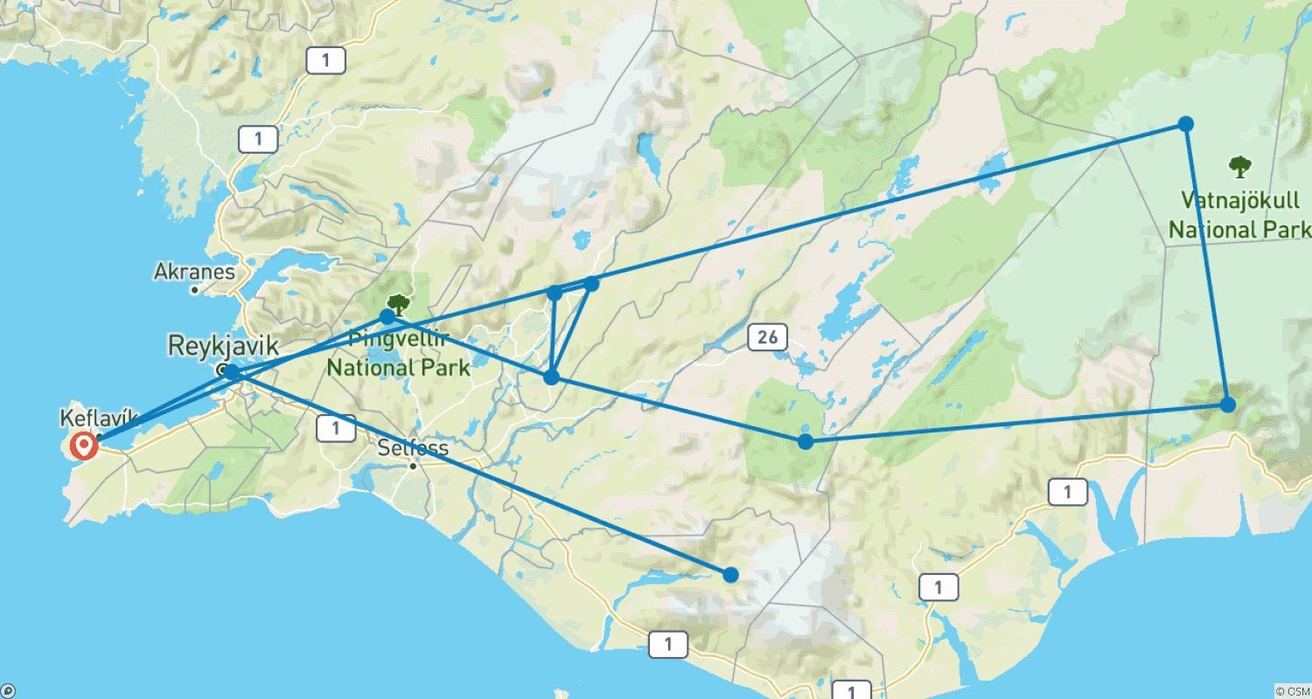

Tour ID: 260255  
Tour Name: Iceland - Adventure Highlands for Solo Travelers

Tour destinations: ['Keflavik', 'Reykjavik', 'Geysir', 'Gullfoss', 'Hveravellir', 'Akureyri', 'Myvatn', 'Askja', 'Landmannalaugar', 'Vik']

Tour destinations images:

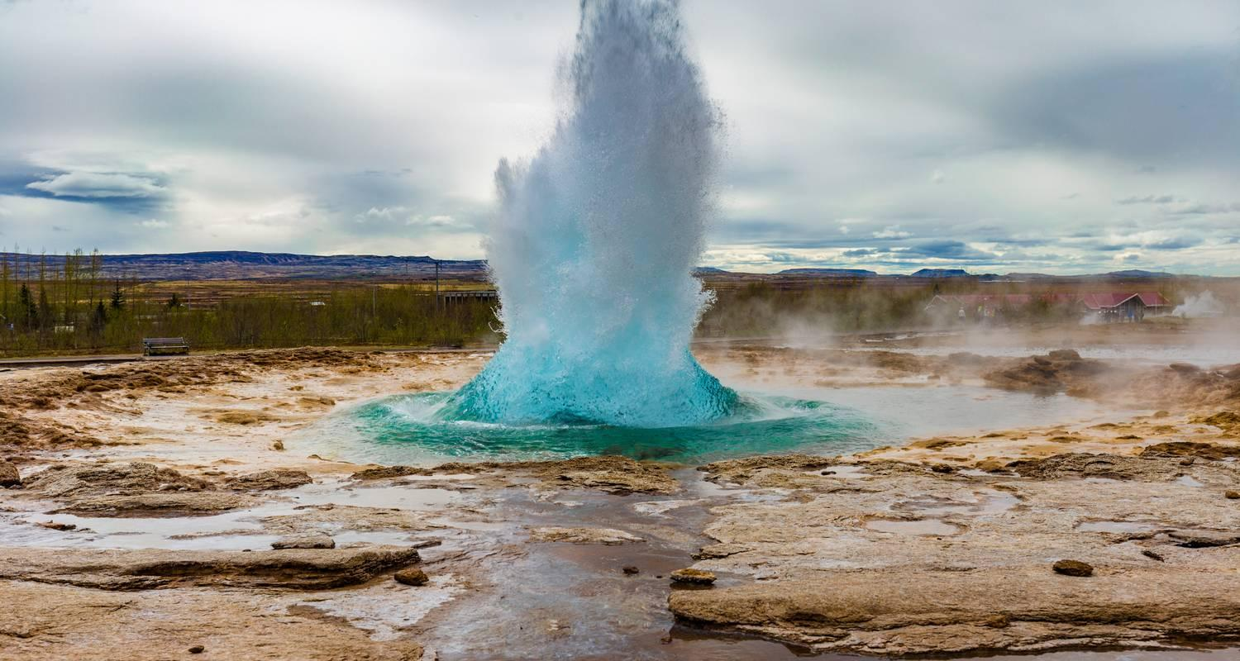



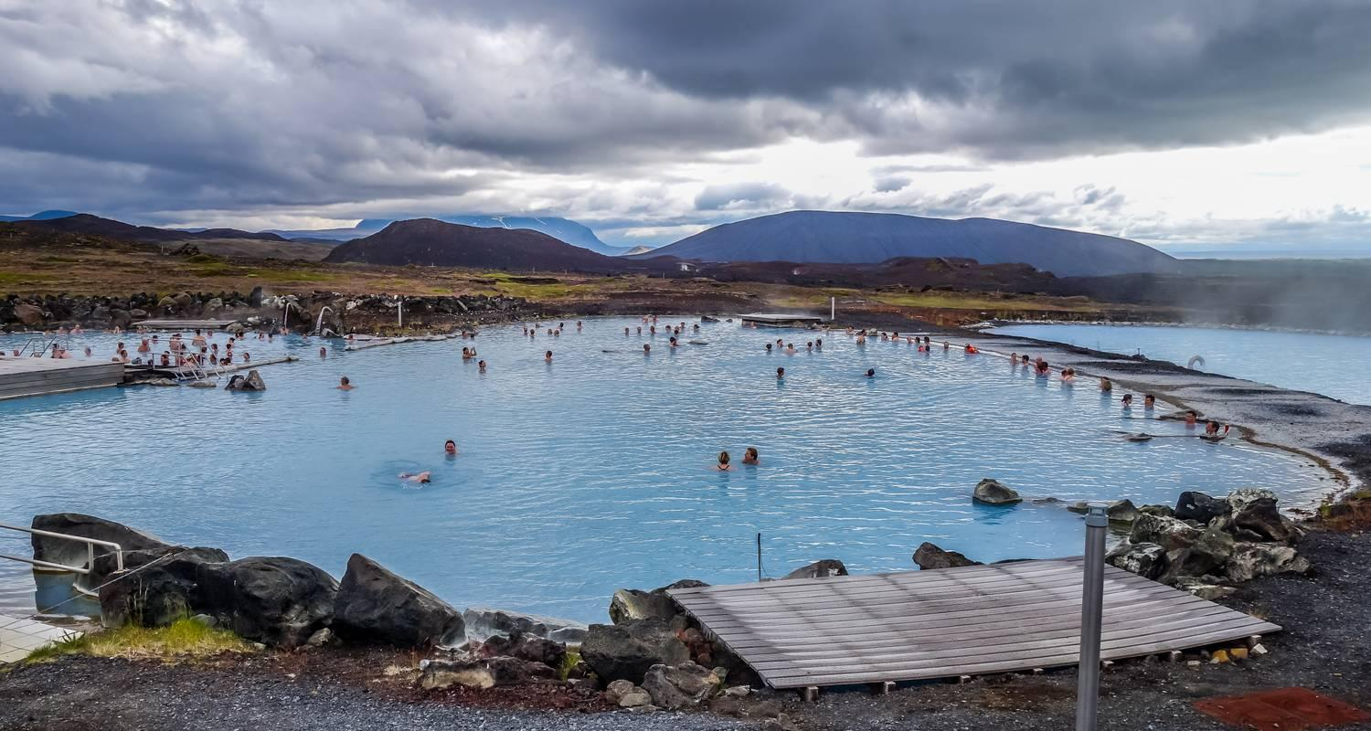

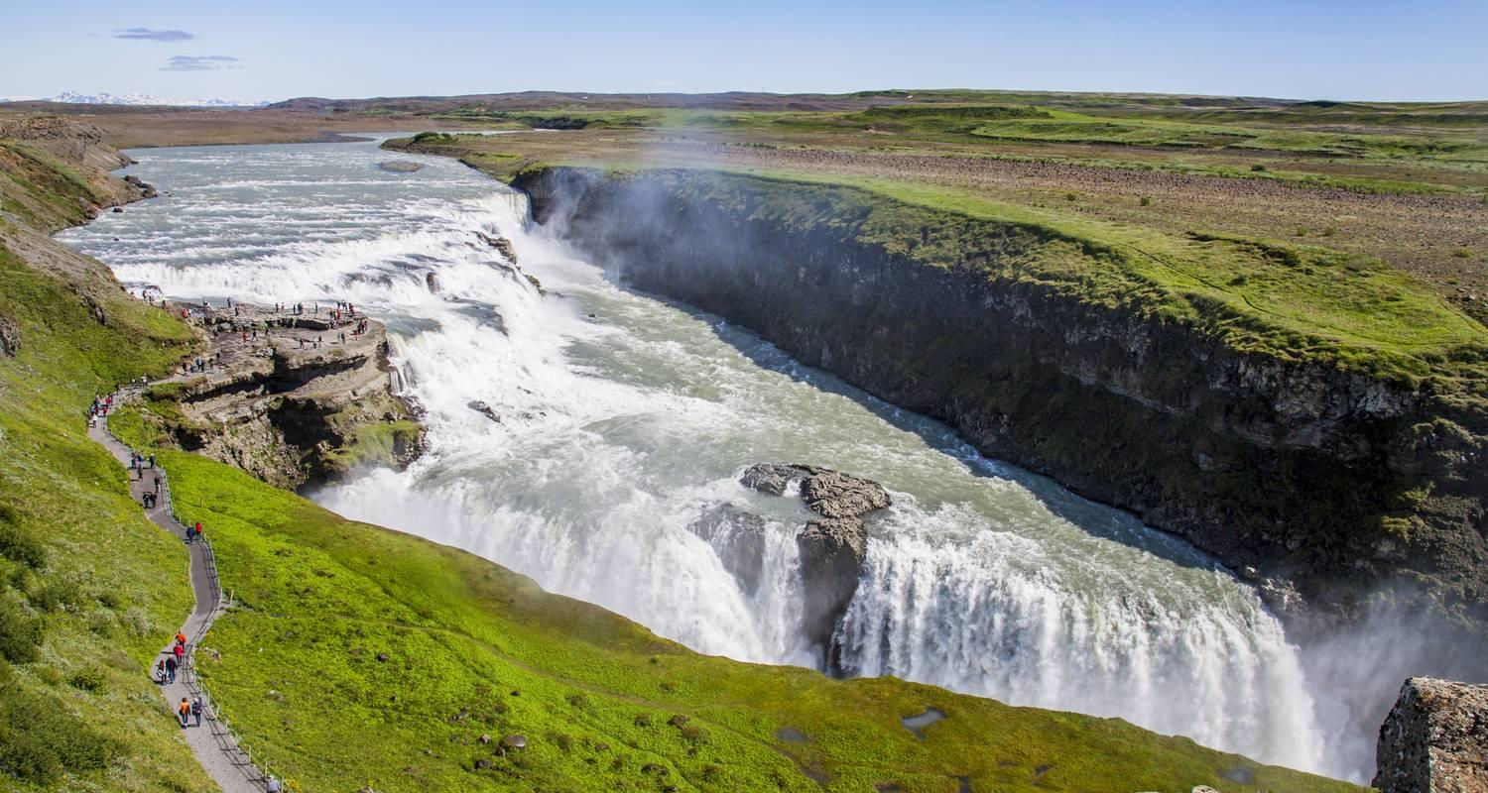

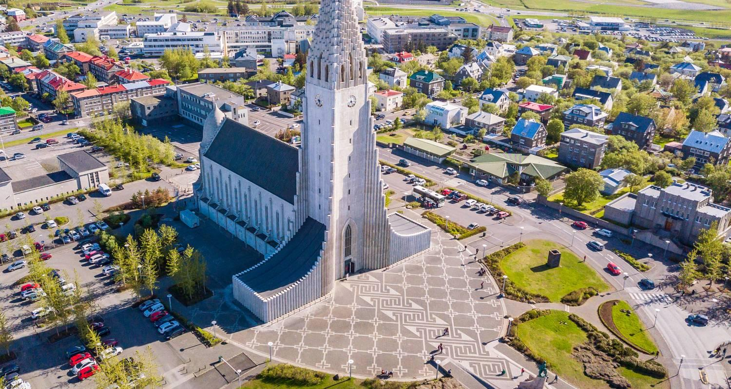





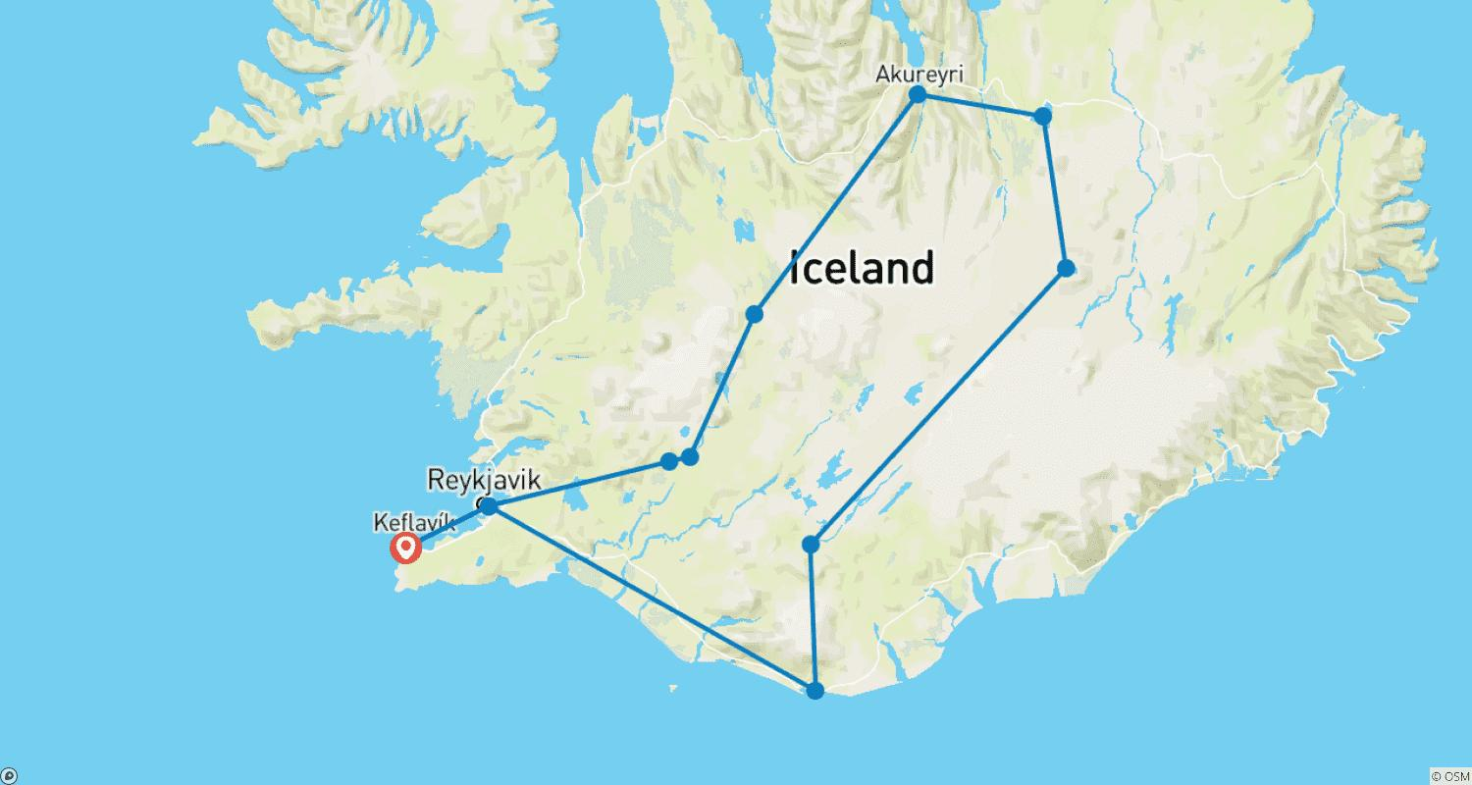

Tour ID: 260321  
Tour Name: Ultimate Arctic Voyage: From Svalbard to Jan Mayen to Iceland

Tour destinations: ['Helsinki', 'Longyearbyen', 'Jan Mayen Island', 'Reykjavik']

Tour destinations images:

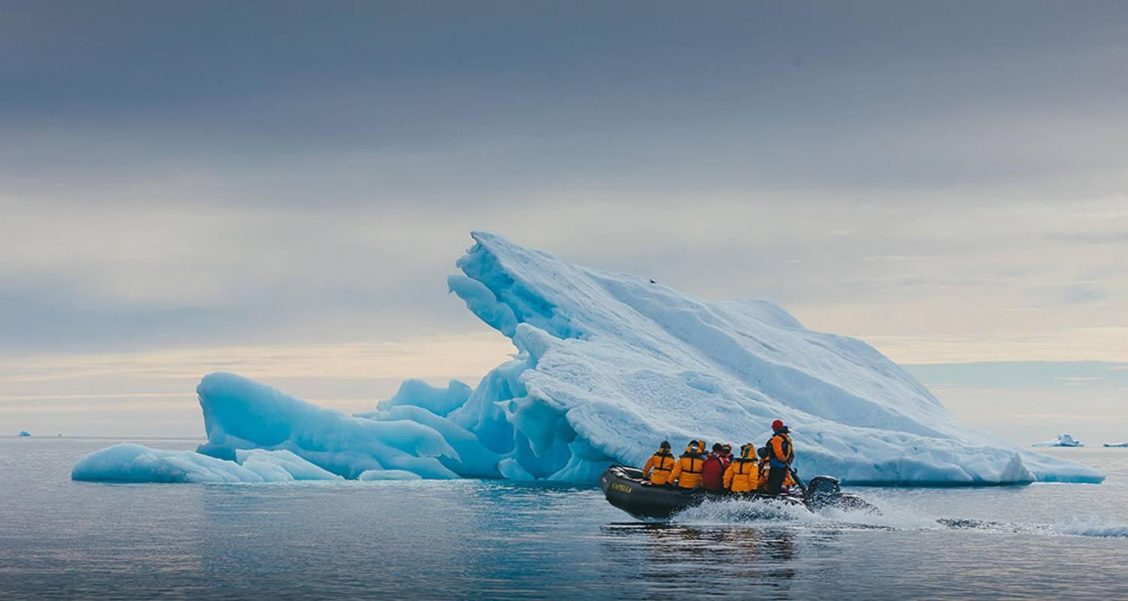

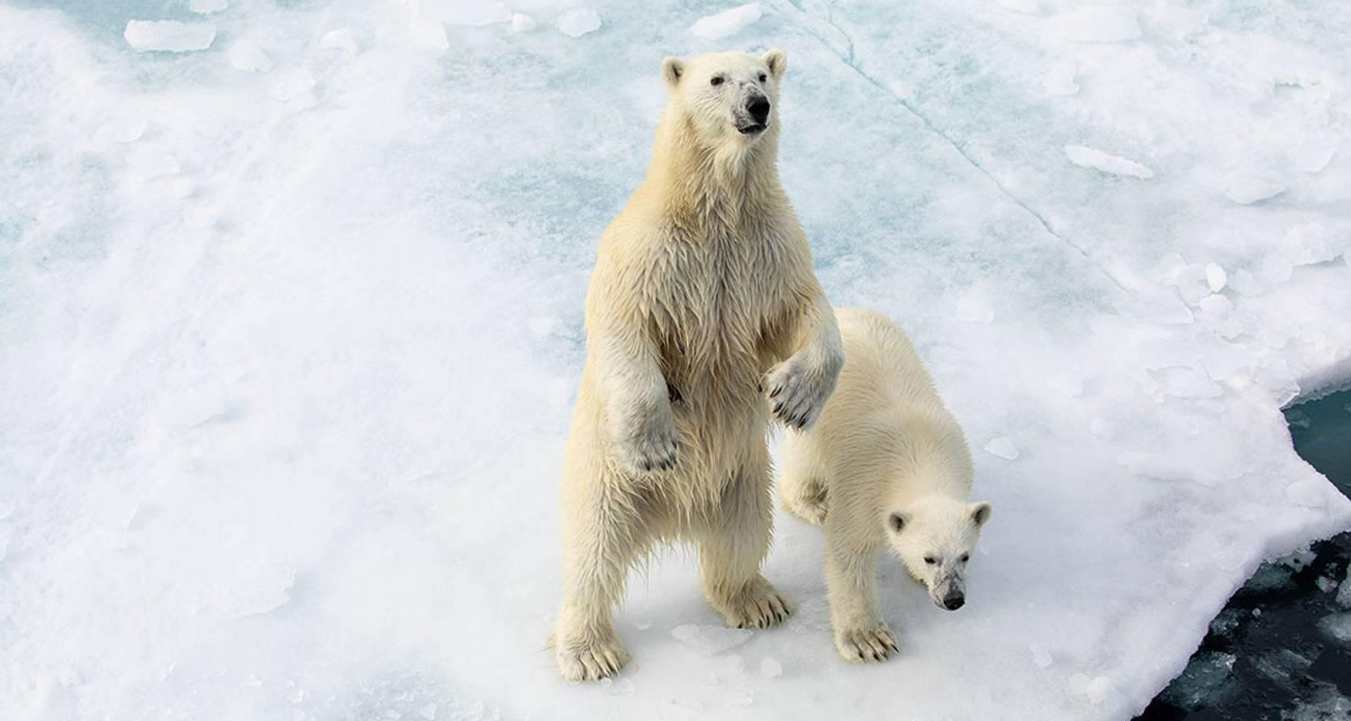

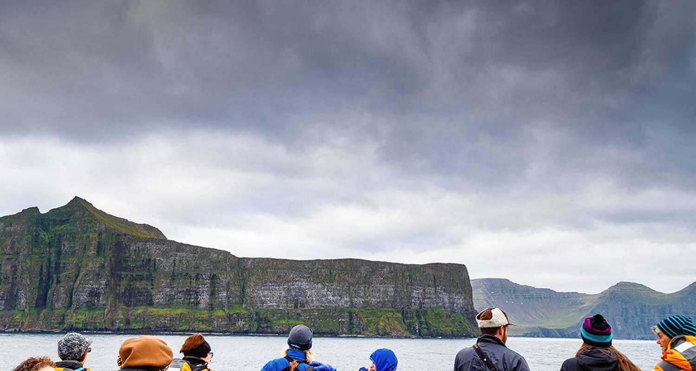

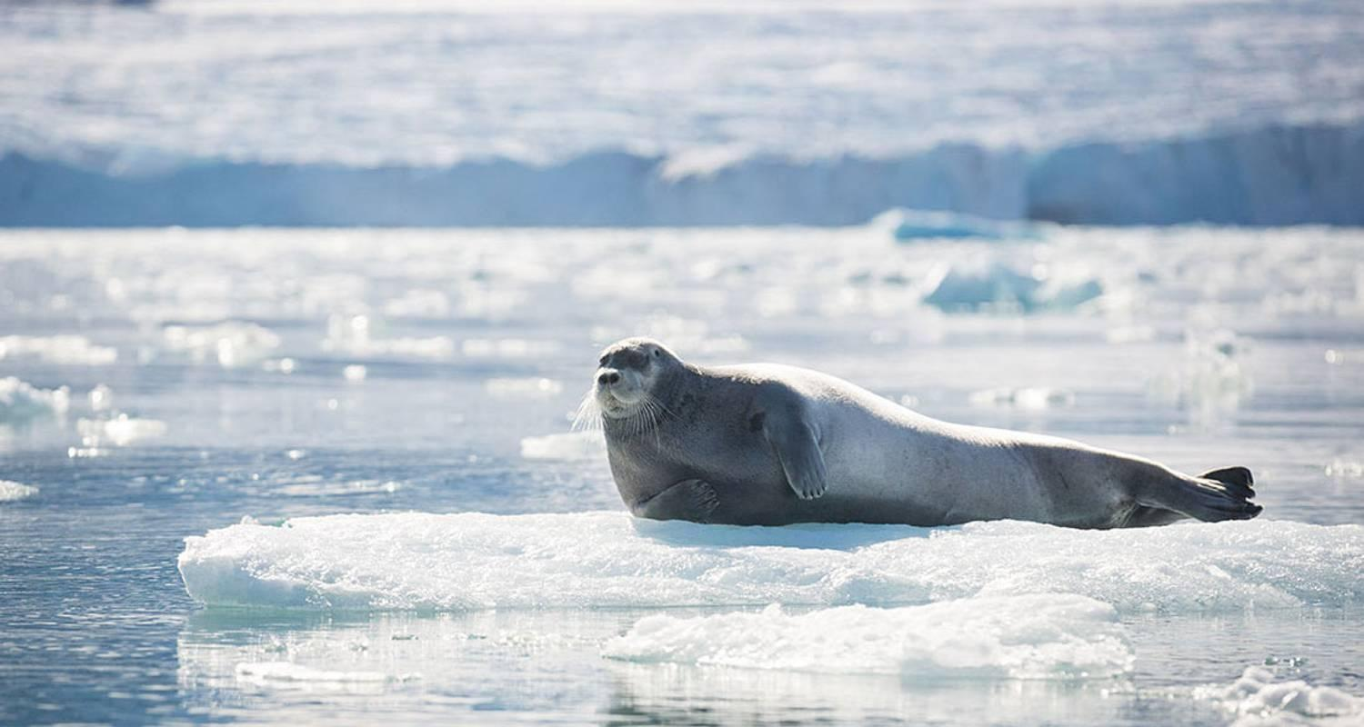

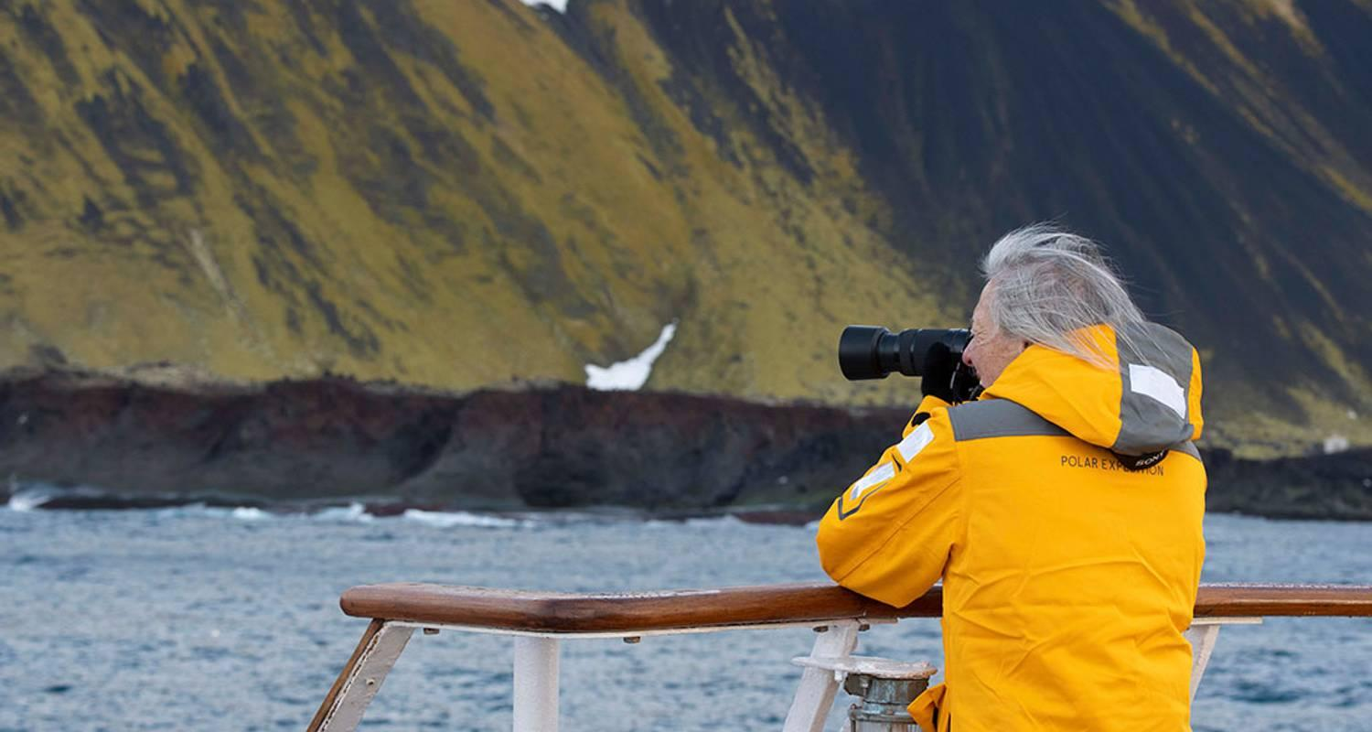

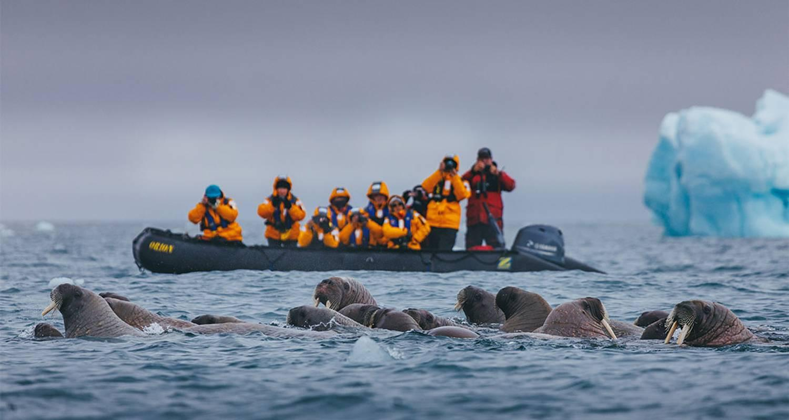

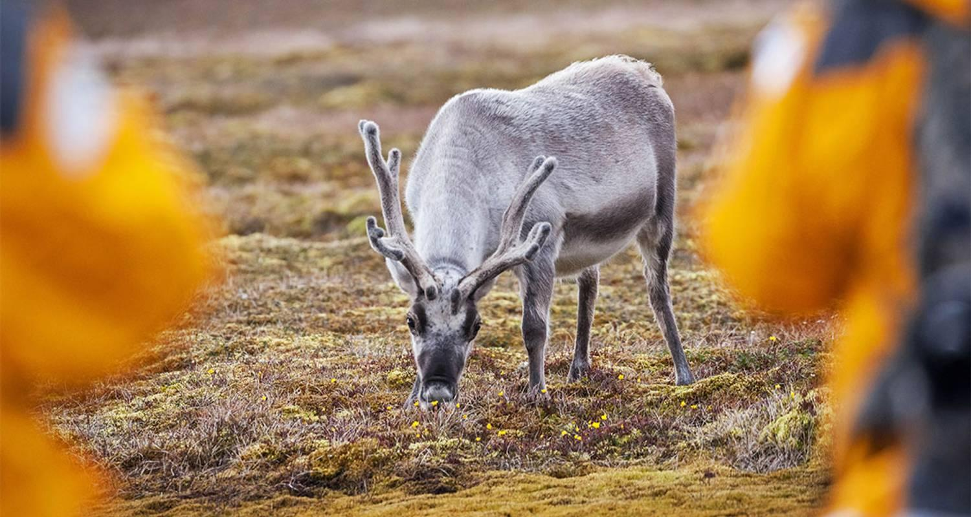

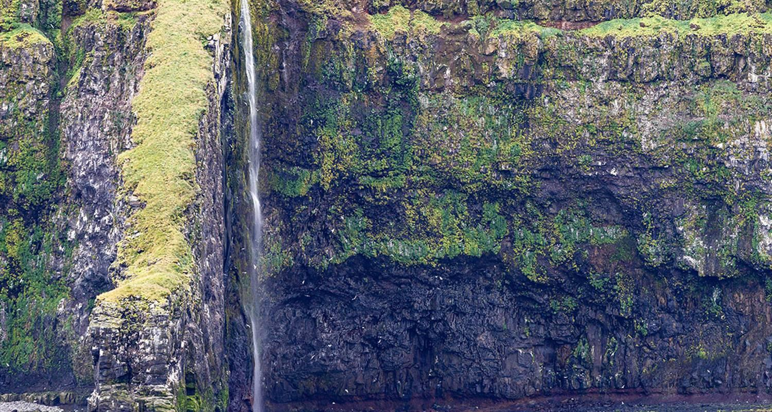

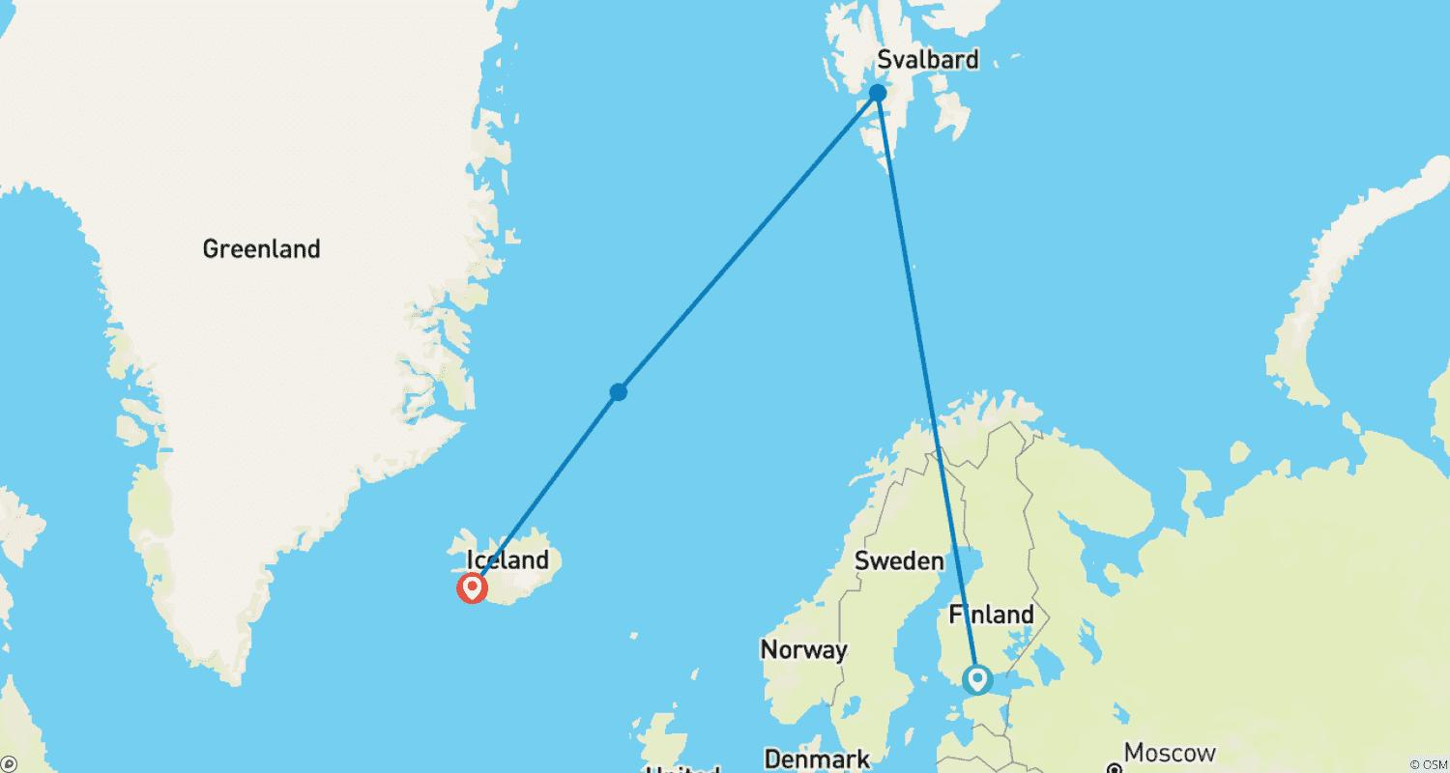

Tour ID: 260606  
Tour Name: 4 Days Private Super Jeep Tour | Landmannalaugar, Thorsmork, South Coast, Golden Circle

Tour destinations: ['Reykjavik', 'Thingvellir National Park', 'Geysir', 'Gullfoss', 'Hekla Volcano', 'Landmannalaugar', 'Hvolsvollur', 'Thorsmork Nature Reserve', 'Hella', 'Seljaland', 'Skogafoss', 'Reynisfjara']

Tour destinations images:

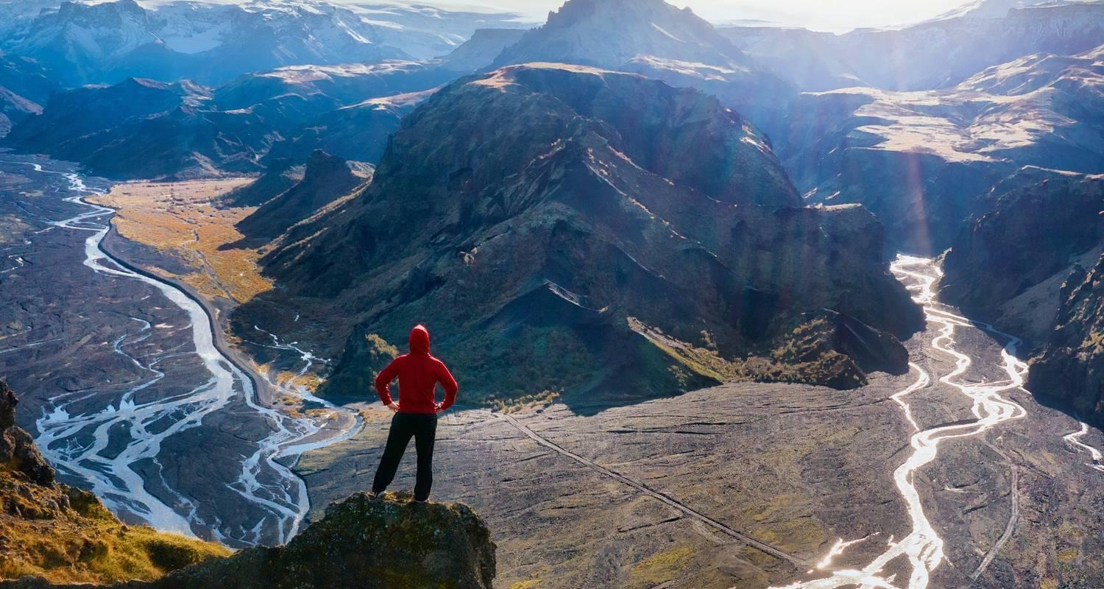

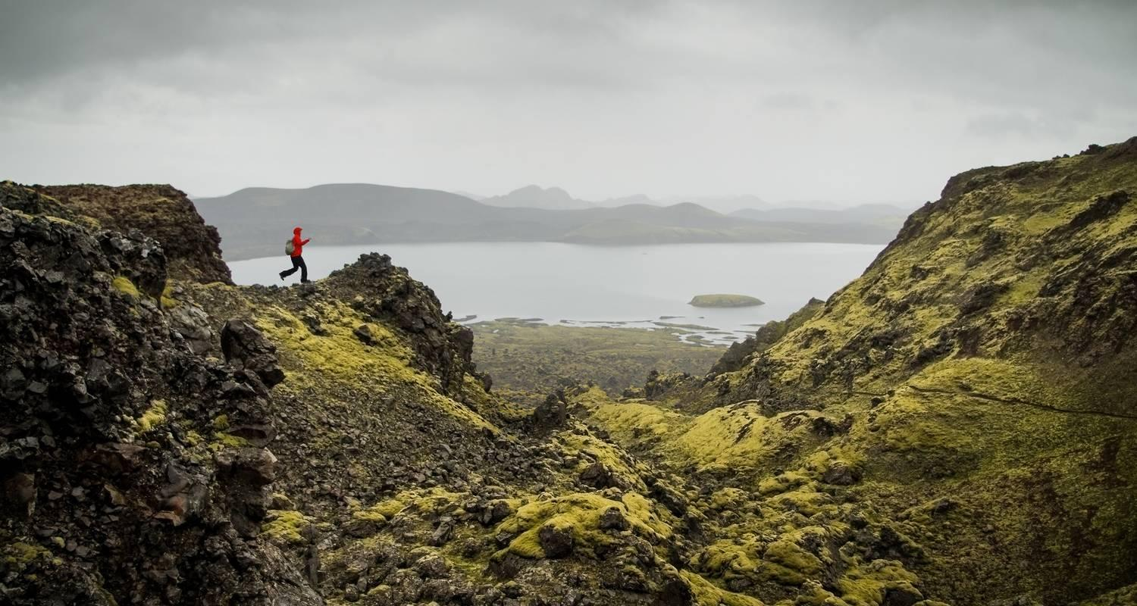

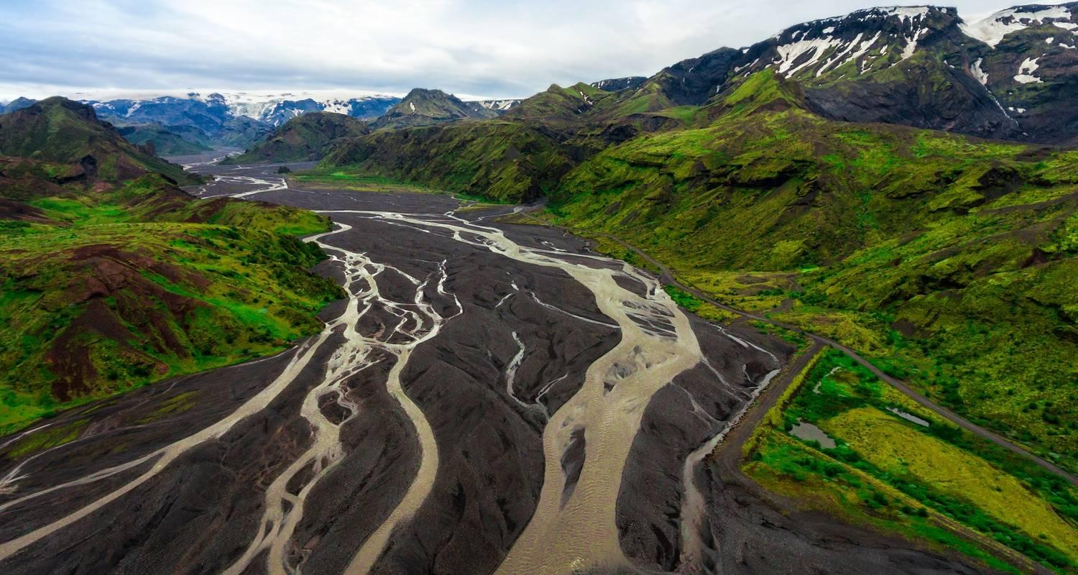

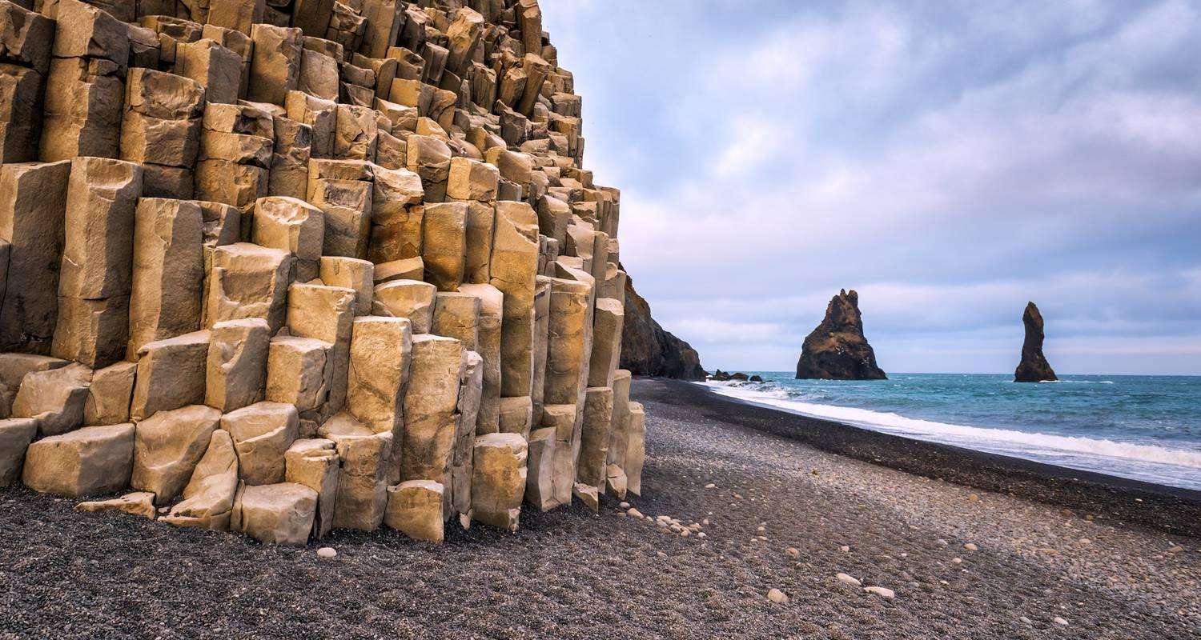

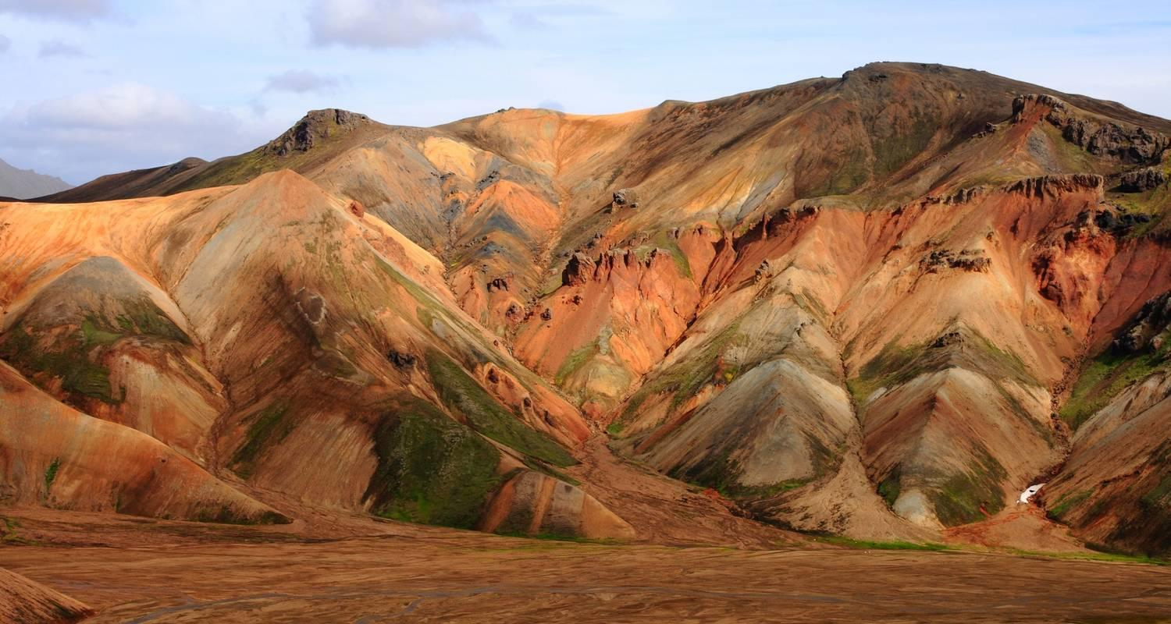

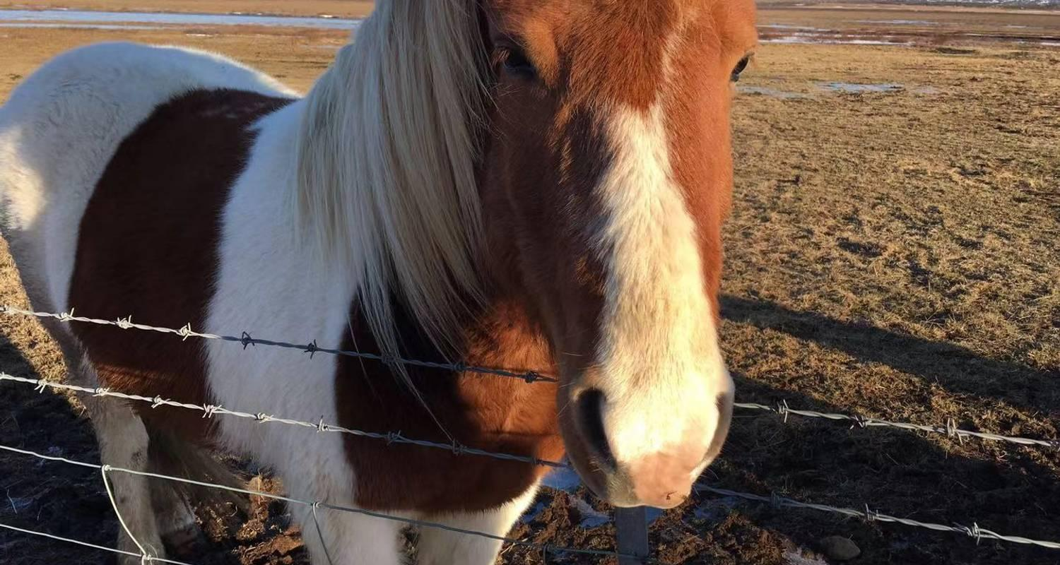

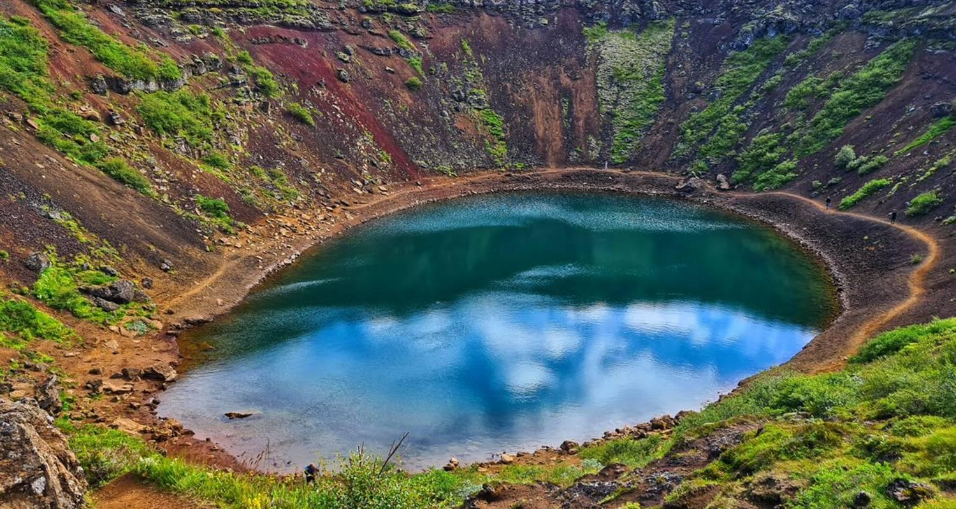

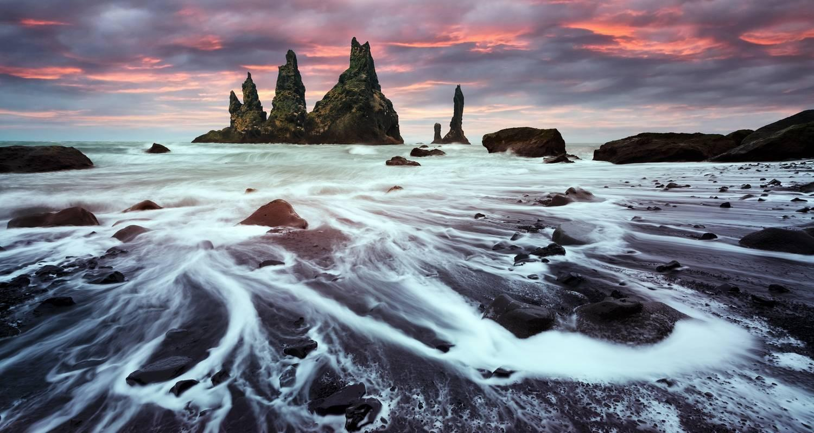

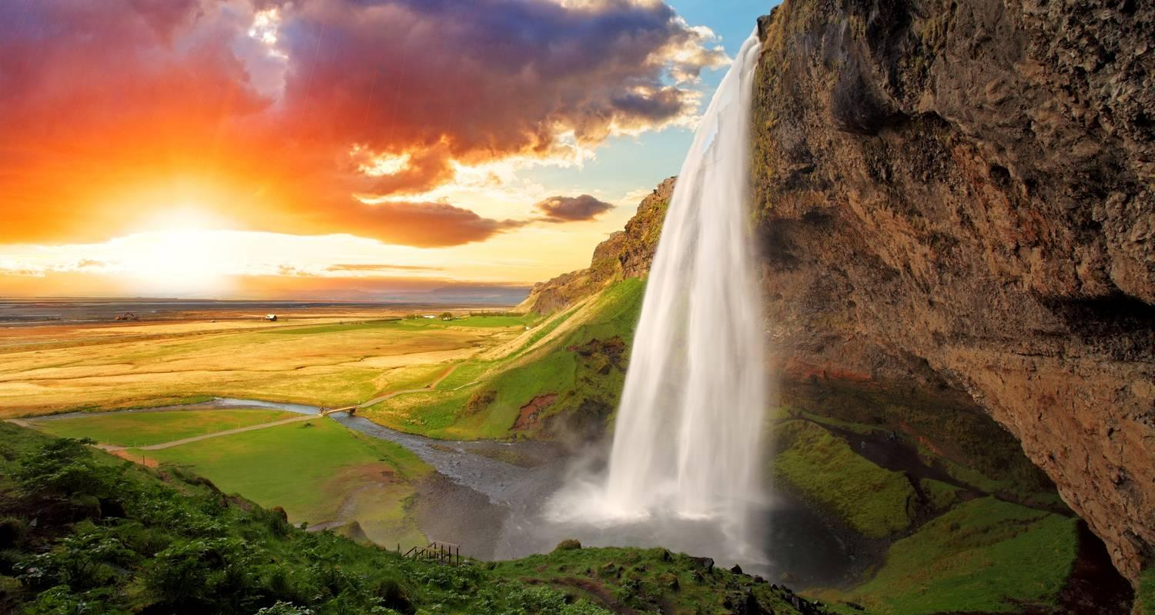

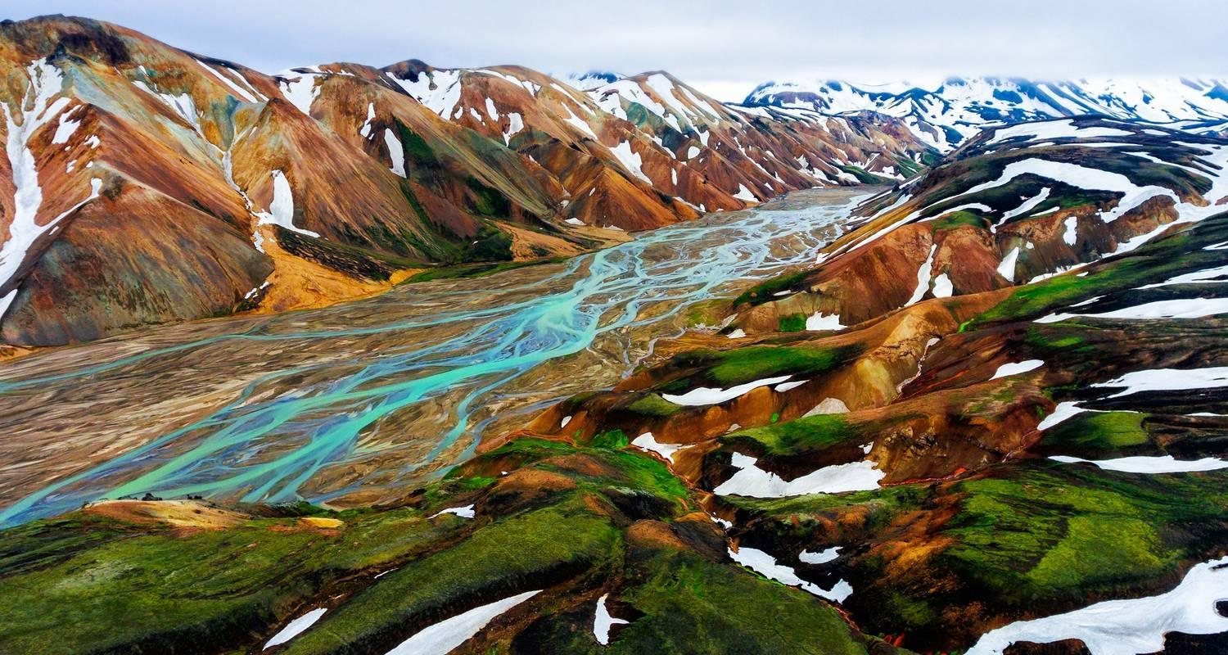

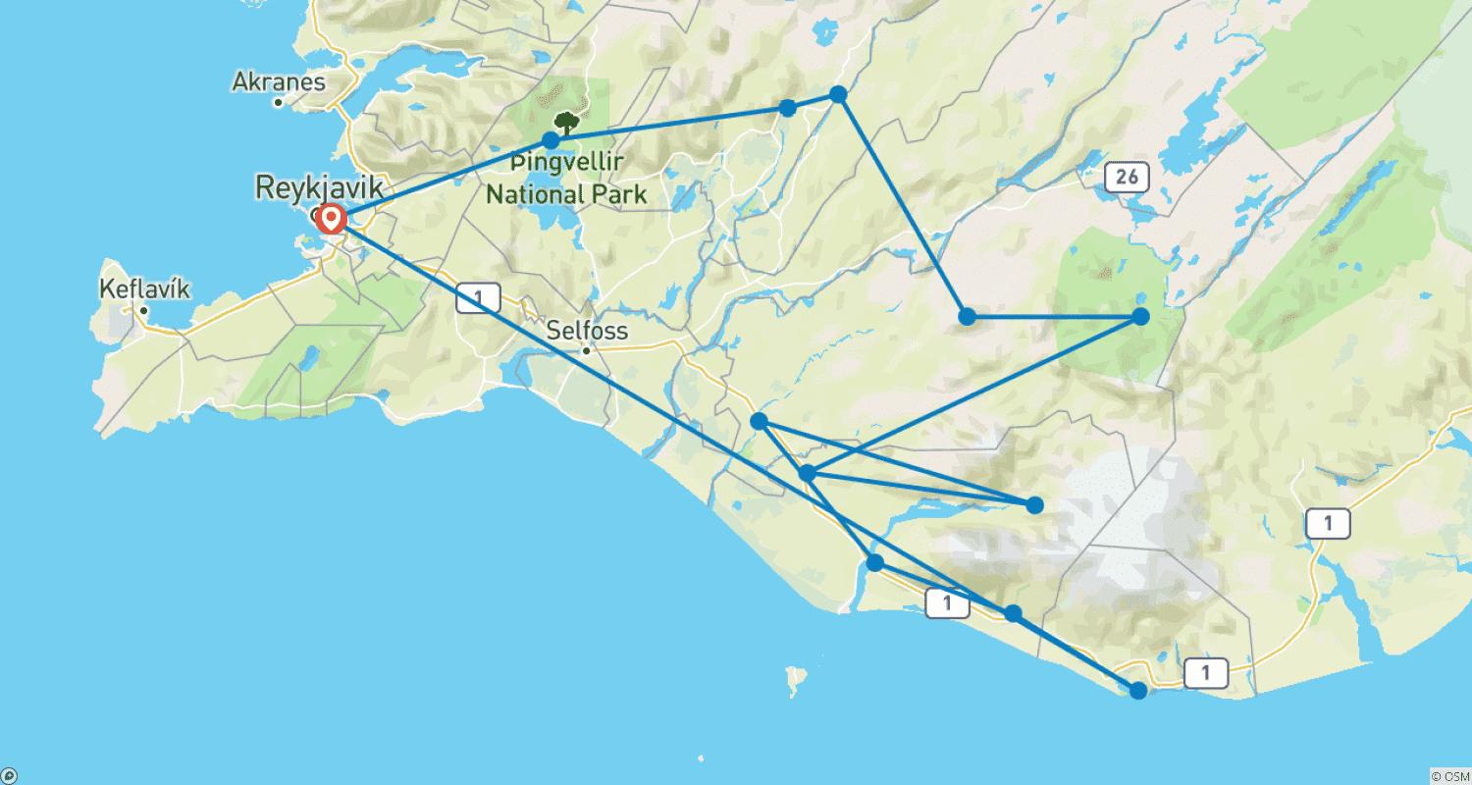

Tour ID: 260611  
Tour Name: 3 Days Private Super Jeep Tour | Landmannalaugar, Golden Circle and South Coast

Tour destinations: ['Reykjavik', 'Landmannalaugar', 'Thingvellir National Park', 'Geysir', 'Gullfoss', 'Skogafoss', 'Seljaland', 'Reynisfjara', 'Reykjadalur']

Tour destinations images:









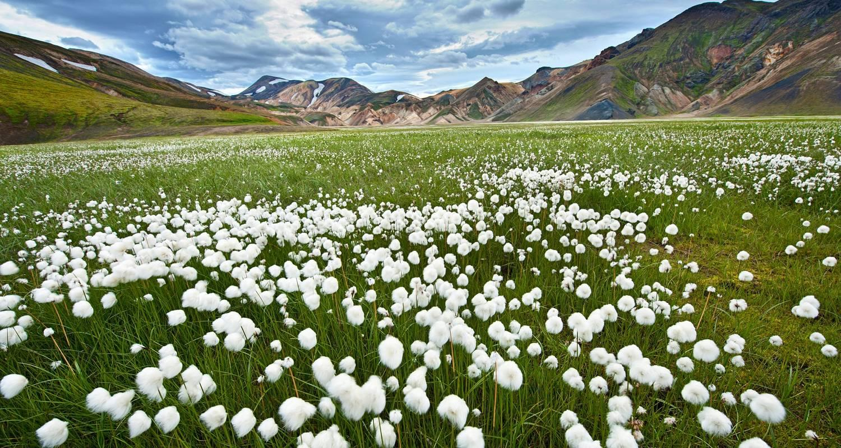









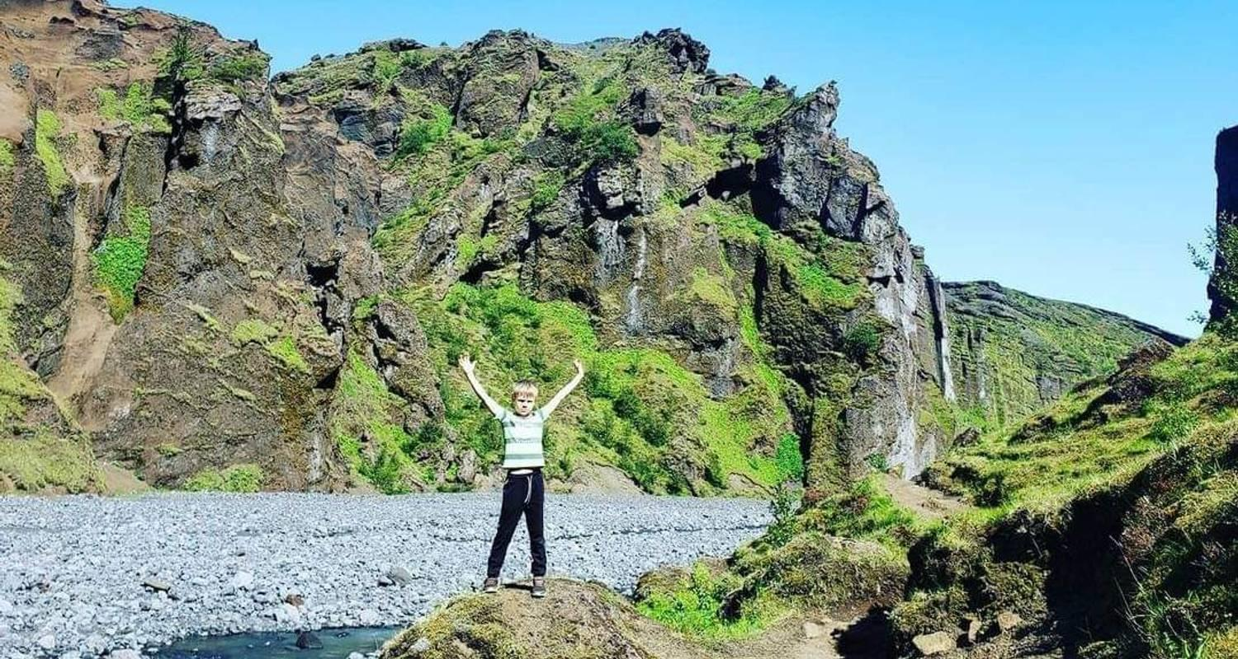

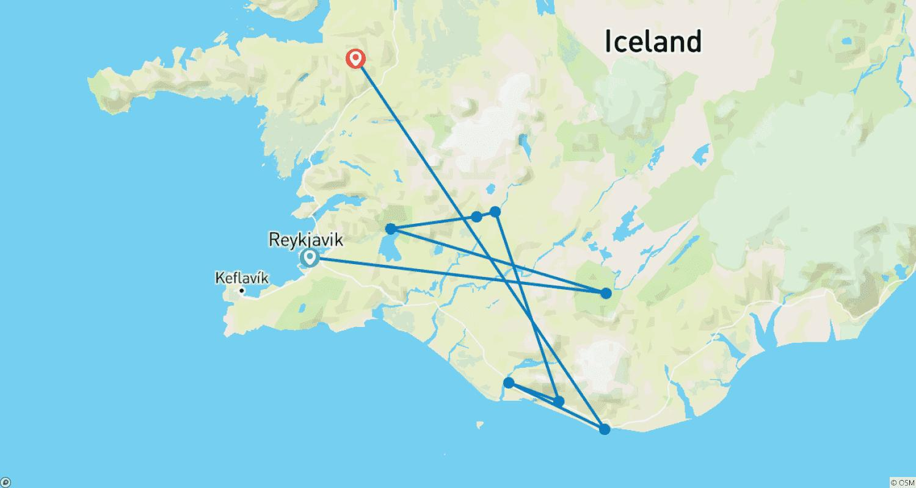

Tour ID: 260616  
Tour Name: 3 Days Private Super Jeep Tour | Landmannalaugar, Thorsmork and Golden Circle

Tour destinations: ['Reykjavik', 'Landmannalaugar', 'Thorsmork', 'Thingvellir National Park', 'Geysir', 'Gullfoss']

Tour destinations images:

